Class 1 Nursery Children Home Learning Activities

Week commencing: Monday 22nd June 2020

This week the planning is based around the book Zog by Julia Donaldson. If you have this book please share it with your child. If not, please click on the following link https://www.youtube.com/watch?v=9_LmS3q4E6k where you will be able to read the book with your child. Most of the activities this week are based around Zog.

 | Activity 1 | Activity 2
Maths | 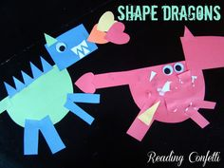  Talk about the different shapes used to make the dragons. How many triangles have you used? How many rectangles? Etc. | 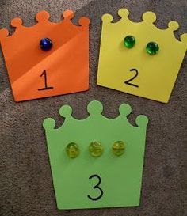  Get your grown up to draw some crowns with numbers on or use plates and count out different things you have in the house. For instance count out 5 grapes, or 7 pieces of Lego/Duplo, or 8 dolls etc.
English | 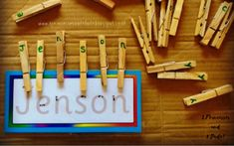  Get your child to match the letters in their name. | 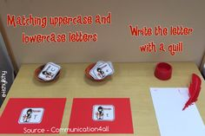  Get your adult to write the letters of the alphabet in upper case and lower case letters and try to match them together. Have a try at writing some of the letters.
Creative | 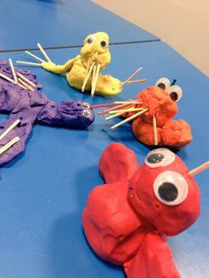  Make Zog using playdough and any resources you have available at home. | 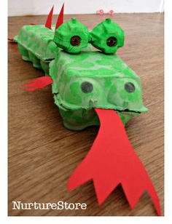  Use some cardboard boxes to make your own dragon.

In addition, if your child is due to start school in September, please can you get your child to try doing the following activities
- practise writing their name in a pre-cursive style
- draw attention to signs that they may recognise around them, such as Tesco, Sainsbury, McDonalds etc
- talk about graphemes (letters) that they may see in the environment
- try using their pincer grip (pencil grip) in a variety of situations, such as picking up cherrios from a plate, using a peg to move pom poms from one place to another
- practise counting – count the number of stairs in your house, the number of grapes on your plate etc.
- practising throwing and catching a large ball

Please contact me via email on mhorrell@exmoorlink.org if you need any further guidance.

