Class 1 Nursery Children Home Learning Activities
Week commencing: Tuesday 14th April 2020
Please contact me via email on mhorrell@exmoorlink.org if you need any further guidance, or if you would like to share your activities online with the rest of our class please visit our private class 1 home learning Facebook page and upload a photo of you and your child doing the activity.
 | Activity 1 | Activity 2
Maths  Mathematics – Number  - Number - Recites numbers in order to 10 (30-50 months) | 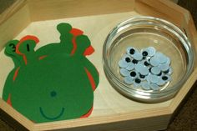  Roll a dice or get a parent to tell you a number and count out that many eyes to put on your alien. | 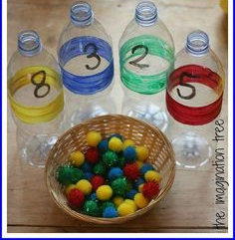  Count pom poms or screwed up paper and put the correct number into the bottle
English  Literacy – Writing  - Sometimes gives meanings to marks as they draw and paint (name writing) (30-50 months) | 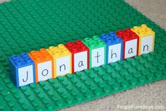  Using Duplo blocks, put the letters in your name in the correct order | 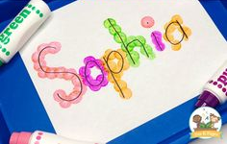  Use felt tip pens, crayons or pencils to go over your name. Can you write your name independently?
Creative  Expressive Arts & Design – Exploring Using media and materials  - Explores colour and how colours can be changed (30-50 months) | 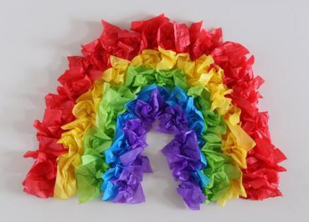  Make a rainbow using tissue paper | 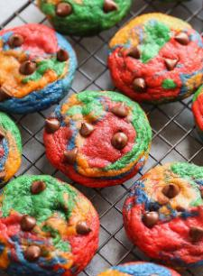  Make some Rainbow cookies  (see recipe below)  Get children to weigh ingredients and talk about what they have made and how they made it.

Rainbow Chocolate Chip Cookies
- Author: Cookies & Cups
- Prep Time: 15 mins
- Cook Time: 9 mins
- Total Time: 24 mins
- Yield: 36 cookies 1x
- Category: Cookies
- Method: Baking
- Cuisine: Dessert
★★★★★ 4.5 from 4 reviews

Description:
Rainbow Chocolate Chip Cookies are thick and soft rainbow cookies, that just happen to be some of the best chocolate chip cookies ever!

Ingredients:
- 1 cup butter, room temperature
- 1 cup granulated sugar
- 1/2 cup light brown sugar
- 2 teaspoons vanilla
- 2 eggs
- 1 teaspoon kosher salt
- 1 teaspoon baking soda
- 3 cups flour
- 2 cups chocolate chips
- 4 different colors food coloring.

Instructions:
- Preheat the oven to 350°F. Line a baking sheet with parchment paper and set aside.
- In the bowl of your stand mixer fitted with the paddle attachment mix the butter and both sugars together for 2 minutes on medium speed until light and fluffy. Add in the egg, vanilla, salt, and baking soda and continue mixing for 1 minute until smooth, scraping the sides of the bowl as necessary.
- Turn the mixer to low and add in the flour, mixing until just incorporated.
- Stir in the chocolate chips evenly.
- Divide the cookie dough into 4 equal portions. Using the food coloring, color the doughs as desired.
- Roll each colored dough into approximately a 15-inch rope.Place each colored rope next to each other on a large piece of cling wrap. Wrap the cling wrap up tightly, pressing the doughs together forming a large log. Remove the cling wrap and breaking off the dough with your hands into approximately 2-tablespoon portions. Roll the dough into a loose ball and place it onto the prepared baking sheet and bake for 9 minutes or until the edges are set. Don’t over bake these!!
- Allow the cookies to cool on the baking sheet for 3-4 minutes and then transfer to a wire rack to cool completely.

Notes:
Careful to not over bake these. There is a slightly larger amount of flour in these to ensure thickness, but if you bake them too long, they will get very firm. The cookies might even seem under-baked when you remove them from the oven. This is fine.
Place a few extra chocolate chips on top of the dough, if desired, just to look pretty.

