Remote Learning - Week 8 - 1.3.2021

Hello,

It has been lovely seeing so many of you this week, and I have loved seeing all the work that you have been doing. Some children have written some fabulous stories last week!

This week is our last week following the story of the three little pigs and the reception children will begin to write some sentence’s changing aspects of the story. As a result of adding an additional writing lesson this week, I have cut back on some of the other activities.

I hope you enjoy the activities and I look forward to seeing your fantastic work during the week.

Mia Horrell

Literacy activities

This week we are continuing with the story of The 3 Little Pigs

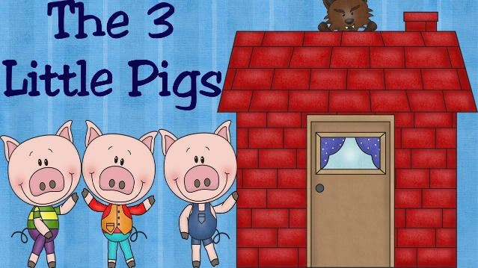

You may have the story at home to share or you can access it by clicking on the following link:
https://www.youtube.com/watch?v=-gdcgnSrUvU

Questions to discuss with your child
How many pigs were in the story? What was the second little pig’s house made from? Which pig do you thing made the best choice? What would you use to build a house? Who blew the straw house down? How do you think each pig felt when they were building their house? What do you think the first and second little pigs learnt from the third little pig?

How many more pigs would need to come along to make 5/6/7/10 etc? What would you like to happen at the end of the story? Can you think of a different ending? Do you think the pigs get on? Why? Would you help your friend/sibling if they were in trouble? Have you helped a friend in trouble? What did you do? Do you think the wolf is kind? Can you explain why you think that?

Nursery activities
Activity One | Activity 2
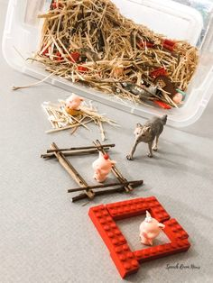  Use resources that you have at home to build the 3 little pigs houses. Can you change the character’s in the story? | 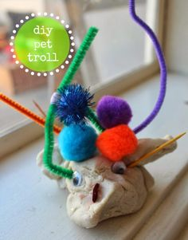  Draw/paint/make some of the new characters and materials that you are going to change in your story.

Reception activities
I have planned for an online literacy session and a practical session. You may choose to do both with your child or you may choose to pick one to complete – we are building up the children’s knowledge and understanding of the story.
Activity One | Activity 2
To recycle a story by changing the characters  Follow the link below and watch the video. Which characters will you change?  https://classroom.thenational.academy/lessons/to-recycle-a-story-by-changing-characters-68rkje  Practical activity to support learning  Use resources that you have at home to build the 3 little pigs houses. Can you change the character’s in the story? | To recycle a story by changing the characters and materials  Follow the link below and watch the video.  https://classroom.thenational.academy/lessons/to-recycle-a-story-by-changing-characters-and-materials-64wk8d  Practical activity to support learning  Draw/paint/make some of the new characters and materials that you are going to change in your story.
Activity 3
To create a story with a familiar lesson learnt

Follow the link below and watch the video. Can you create your own story?

https://classroom.thenational.academy/lessons/to-create-a-story-with-a-familiar-lesson-learnt-65k38c

Practical activity to support learning

Make some puppets to support your new story.

Reading & Phonics activities

Nursery activities

Activity One | Activity Two

Reception activities
I have found some videos that I hope the children will enjoy. They are quite funny and I think may capture the children’s interest and enthusiasm. Therefore, there will be no pre-recorded phonic sessions, instead they will be replaced by these activities.
Activity One | Activity Two
Recap previously learnt phonemes  Recap all the phase 2 phonemes (sounds) – sheet on class do jo and revise the phase 3 phonemes up to /ee/. Please practise these daily with your child to help them learn and retain the different phonemes. | Learn the /igh/ phoneme  Follow the link to learn the new /igh/ phoneme. Make sure you click on the arrows at the bottom of the page to continue through the session.  https://www.bbc.co.uk/bitesize/topics/zvq9bdm/articles/zkhvhbk  Play the /igh/ bingo game with an adult. This has been uploaded onto class dojo.
Activity Three
Learn the /oa/ phoneme
Follow the link to learn the new /oa/ phoneme. Make sure you click on the arrows at the bottom of the page to continue through the session.

https://www.bbc.co.uk/bitesize/topics/zvq9bdm/articles/zh4j47h

Match the /igh/ and /oa/ words on this worksheet. This worksheet has been uploaded onto class dojo.

Maths activities

Nursery activities

Activity One | Activity Two
Match the numbers and try to recognise them. (If your child can count further, please write higher numbers for them) | Match the numbers to the numicon oices and try to write the numbers.
Activity Three | Activity Four
Put the number cards into the correct column. | Paint the numbers 1 to 5 with adult assistance.

Reception activities
Activity One

Work through the sessions on the White Rose Maths Website (link below) There are PowerPoint slides, a video and an activity for each session. Try to complete at least 4 sessions of maths work this week. Please load your work on class DoJo.

https://whiterosemaths.com/homelearning/early-years/building-9-10-week-2/

Understanding the World activity

Reception & Nursery activity
I have planned for an online session and a practical activity. You may choose to do both with your child or you may choose to pick one to complete.

To create a healthy dish

Follow the link below and watch the video. Can you make a healthy fruit salad?

https://classroom.thenational.academy/lessons/to-create-a-healthy-dish-6djp2d

Practical activity to support learning
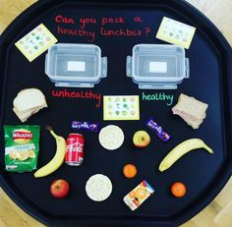
Help a grown up to make a healthy packed lunch box.

Expressive Arts and Design activity

Reception & Nursery activity
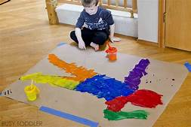
Paint a picture of your body.

Physical Development activities

Reception & Nursery activities

Join in with some Joe Wicks workouts to give yourself some exercise (link below if you can’t find any online).

https://www.bing.com/videos/search?q=joe+wicks+youtube&docid=608033495697329819&mid=CA6D0850BB803BEC7EC7CA6D0850BB803BEC7EC7&view=detail&FORM=VIRE

