Class 1 Reception children Home Learning activities
Week commencing: Monday 11th May 2020
This week the planning is based around the book The Very Hungry Caterpillar by Eric Carle. If you have this book please share it with your child. If not, please click on the following link https://youtu.be/75NQK-Sm1YY where you will be able to read the book with your child. Most of the activities this week are based around the book The Very Hungry Caterpillar.

This week, I am continuing to trial a new website with lessons and video clips for your child to complete with you. The website is outlined in the table below, with the web address, I would very much value you feedback at the end of the week. Please can you let me know if you like the National Academy to support learning. Thank you.
Weekly Focus | Activity 1 | Activity 2 | Activity 3 | Activity 4
Maths  Mathematics - Number  - They solve problems, including doubling, halving and sharing. (ELG) |  | https://www.thenational.academy/  Please visit the above website and go onto week 4, Monday. Please complete the activities on this video and talk about it with your adult |  | https://www.thenational.academy/  Please visit the above website and go onto week 4, Monday. Please complete the activities on this video and talk about it with your adult
English  Literacy – Reading  - They demonstrate understanding when talking with others about what they have read. (ELG)  Literacy – Writing  - Children use their phonic knowledge to write words in ways which match their spoken sounds. (ELG) | Read the story with your child and enjoy looking at the beautiful artwork  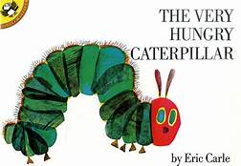  If you don’t have the story use the following link https://youtu.be/75NQK-Sm1YY | 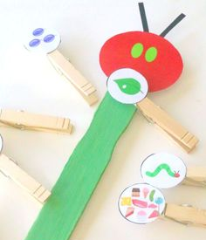  Draw some pictures of the fruit that the Hungry caterpillar ate in the story. Peg the pictures in the correct order of the story. | Try to write a food diary of the very hungry caterpillar! This will last over 2 days – how much will you clever clogs manage to write? (Link’s for | Try to write a food diary of the very hungry caterpillar! This will last over 2 days – how much will you clever clogs manage to write?
Creative  Expressive Arts & Design – Exploring & using media and materials  - They safely use and explore a variety of materials, tools and techniques, experimenting with colour, design, texture, form and function. (ELG)  - Constructs with a purpose in mind, using a variety of resources (40-60 months)  Physical Development – Health & Self-care  - Shows some understanding that good practices with regard to exercise, eating, sleeping and hygiene can contribute to good health. (40-60 months) | 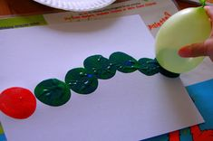  Paint a picture of the very hungry caterpillar. You can focus on the caterpillar, use balloons and/or have a go at painting the background. With an adult have a go at counting the number of caterpillar segments and get your grown up to ask you questions such as one more/one less. | 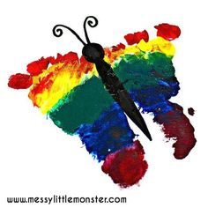  Paint your feet to make a butterfly. If you are feeling very clever write a sentence to tell me what the caterpillar did and what he changed into. Get your adult to upload your writing onto Class DoJo. | 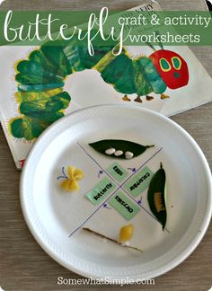  Make a lifecycle of a butterfly. Use things that you can find at home, such as pasta, leaves and seeds. Get your adult to upload your butterfly lifecycle onto Class DoJo. | Make some very hungry caterpillars and decorate them how you would like. I will look forward to seeing your fantastic creations on Class DoJo. Please find a cupcake recipe on the school website.

Over the next couple of weeks, I will be communicating with parents during the new class DoJo app – please can you make sure that you have accepted the invitation to your child’s learning so that we can work together to support your child’s learning at home. I love seeing photos of your child completing some of the activities.

Please contact me via email on mhorrell@exmoorlink.org if you need any further guidance.

