Class 1 Reception children Home Learning activities
Week commencing: Monday 20th April 2020
This week the planning is based around the book Supertato by Sue Hendra and Paul Linnet. If you have this book please share it with your child. If not, an electronic copy is available on the school webpage, where you will be able to read the book with your child. Most of the activities this week are based around the book Supertato.
Weekly Focus | Activity 1 | Activity 2 | Activity 3 | Activity 4
Maths  Mathematics - Numbers  - Counts objects to 10 and beginning to count beyond 10 (40-60 months) | 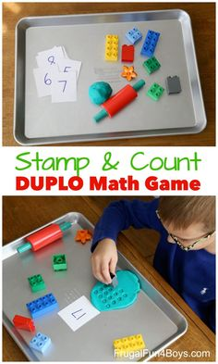  Use Duplo and plasticine and show the children a number. Then get them to use the Duplo to stamp that many holes in the plasticine (see picture for clarification). Include numbers up to 20 and beyond if your child finds it easy. | Please check the school website for activities based around the book Supertato – Day 1 | 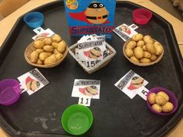  Write numbers and count the correct number of potatoes into bowls. Include numbers up to 20 and beyond if your child finds it easy. | Please check the school website for activities based around the book Supertato – Day 2
English  Literacy - Writing  - Attempts to write short sentences in meaningful contexts (40-60 months)  - Links sounds to letters, naming and sounding the letters of the alphabet | Use the sound mat to help your child to recap and recall all the phase 3 phonemes – this may take a couple of weeks. | 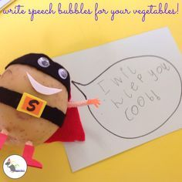  Write a sentence that Supertato may say. Share your sentence on the class one Facebook page. | Get your child to practise reading and writing the tricky word list – this may take a couple of weeks. | 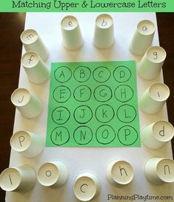  Match upper case and lower-case letters
Creative  Expressive Arts & Design – Being Imaginative  - Creates simple representations of events, people and objects (40-60 months) | 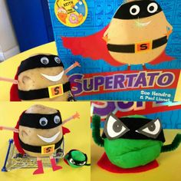  Use a potato and decorate to make a Supertato | 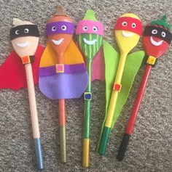  Use some spoons or cut out cardboard spoons and decorate to make Supertato | 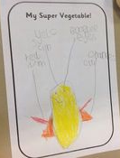  Draw a picture of a Supertato and label. Share your work on class one’s Facebook page. | 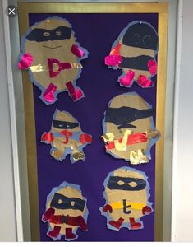  Paint a picture of Supertato

During this week you should receive an invitation to join class one’s Dojo Bug’s by email. Please join because this will become the main way of communicating with parents.

Please contact me via email on mhorrell@exmoorlink.org if you need any further guidance, or if you would like to share your activities online with the rest of our class please visit our private class 1 home learning Facebook page and upload a photo of you and your child doing the activity.

