13.01.21 WALT: Know that Christian’s believe God forgives people who are sorry.
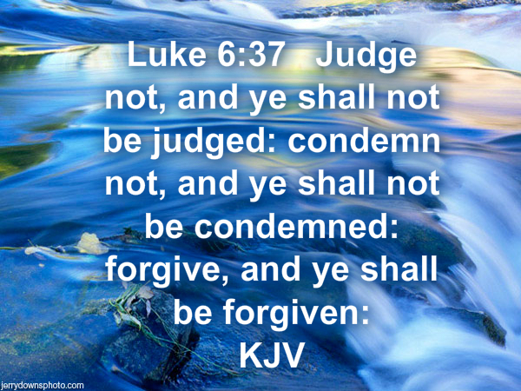

Draw a picture of someone who needs forgiving. Don’t forget to say why!

