Class 1 Reception children Home Learning activities

Week commencing: Monday 1st June 2020

This week the planning is based around the book The Snail and the Whale by Julia Donaldson. If you have this book please share it with your child. If not, please click on the following link https://www.youtube.com/watch?v=hheolVGZVvs where you will be able to read the book with your child. Most of the activities this week are based around The Snail and the Whale.

Weekly Focus | Activity 1 | Activity 2 | Activity 3 | Activity 4
Maths  Mathematics – Shape, Space & Measure  - Uses familiar objects and common shapes to create and recreate patterns (30-50 months)  - They can recognise, describe and re-create patterns (ELG) | 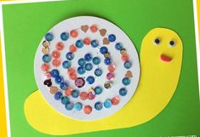  Get your adult to help you cut out a snail shape. Then decorate it using your finger print and 2 colours or using two different colours/objects. See if you can make a repeating pattern. |  | Sped some time today, thinking about 1 or 2 more than a given number. You can do this in a playful context, i.e. while playing with cars, dinosaurs, teddies or dolls or in a more formal context using the above slide to stimulate thinking. The focus is being able to quickly say the numbers before and the numbers after a given number – lots of practise makes perfect! | Complete the one more and one less worksheets
English  Literacy – Reading  - Links sounds to letters, naming and sounding the letters of the alphabet (30-50 months)  - Begins to read words and simple sentences (30-50 months)  - They use phonic knowledge to decode regular words and read them aloud accurately (ELG)  Literacy – Writing  - Can segment the sounds in simple words and blend them together (30-50 months)  - Attempts to write short sentences in meaningful contexts (30-50 months)  - They write simple sentences which can be read by themselves and others (ELG) | 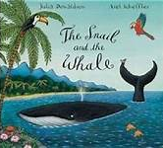  Share this book with your child if you have it at home. If not use the link above to view it on you tube. Enjoy the pictures and get children to predict what might happen next. | 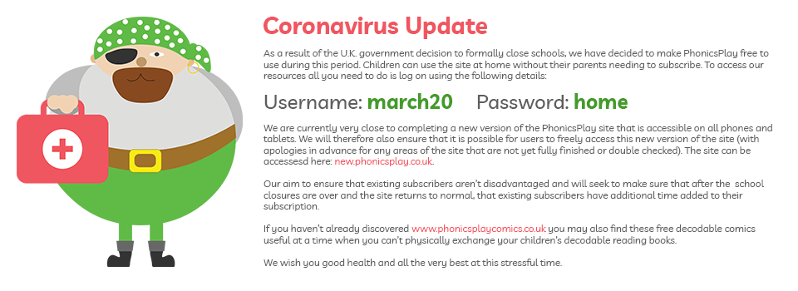  Visit https://www.phonicsplay.co.uk/ and get your child to have a go on some of the phase 3 and phase 4 phonic games | 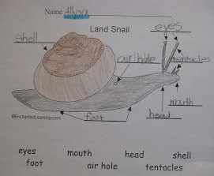  Label a snail using your best pre-cursive writing | 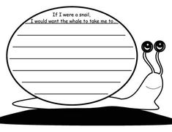  Write a sentence about where you would like to visit if you were a snail travelling on a whale.
Creative  Understanding The World – The World  - They make observations of animals and plants and explain why some things occur and talk about changes (ELG)  Understanding The World – Technology  - They select and use technology for particular purposes (ELG)  Personal, Social & Emotional Development – Managing Feelings & Behaviour  - Children talk about how they and others show feelings about their own and others behaviour and its consequences, and know that some behaviour is unacceptable (ELG) | Find a smooth stone and use paint or felt tip pens to decorate the shell. Can you make a pattern? Ask your grown up to make you some playdough and roll it into a sausage shape to make snail. | 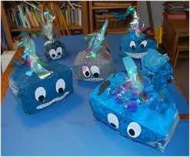  Paint a box blue and decorate to look like a whale – I would love to see some of your super whales on class dojo! | Use coloured tissue paper and decorate a paper plate. Try to think about using colours that look like the sea and colours that may look like a sunset. Then draw and cut out a whale on black paper and stick him onto the plate. If you do not have coloured paper, you could use pictures from magazines or paint or colour your plate. | 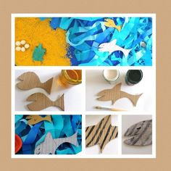  Use am old cardboard box or paper to make the animals in the story snail and a whale. Use these animals to retell the story of Snail and a whale to an audience – you can do this in a socially distanced manner! Remember to rehearse your story lots of times first so that you know the story really well. Perhaps you could ask an adult to film you telling the story and put it on class dojo.

Over the next couple of weeks, I will be communicating with parents during the new class DoJo app – please can you make sure that you have accepted the invitation to your child’s learning so that we can work together to support your child’s learning at home. I love seeing photos of your child completing some of the activities.

Please can you either let me know or let the school office know if you are planning to send your child back to school once school re-opens following Government guidance. This is so that we can start to consider staffing and planning for the return of children. Many thanks.

Please contact me via email on mhorrell@exmoorlink.org if you need any further guidance.

30/5/2020
Dear Parents,
After a great deal of consideration, I have decided not to return to school on the 1st June when nursery and reception children are able to. This is based on personal health issues and me being classed as vulnerable by the Government. I have sought additional advice from my GP who has suggested that at the current time, it would not be recommended for me to be in school. I am obviously very disappointed by this news and am deeply saddened not to be welcoming back all of your children. I hope, however, that you will understand my position. I will still be contactable via email or class dojo.

I will continue to plan for the children both in school and the children who will remain at home. I have already been working closely with staff on site and will continue to do so from home. Class one will be led by Kath Humphries and supported by Anya Yates and Cassie Alderman, all of whom know your children and their needs very well. It is my intention that, as much as possible, the children in school will do a considerable amount of their learning outside.

If you require any further information about how class one will be run during the remaining weeks in school, please don’t hesitate to contact me or a member of staff in school and we will be happy to try and assist you.

