**Year 2 Class 2 - Week 3 planning W/C 25.1.2021**

This pack includes remote home learning for class 2 – year 2

Please use the planning for your child’s correct age group, unless told otherwise. If your child finishes and finds the task easy, then please move onto the extension tasks only.

This pack provides a full week’s worth of work, we will be using the pack in school too.

Please complete the following tasks this week (this is the minimum required amount of work that should be completed this week):

* Three reading tasks
* Three English writing tasks
* Two handwriting tasks
* Three phonics tasks
* Four maths tasks
* One science learning activity
* Three non-core sessions eg art, geography
* Physical activities

(This is the minimum amount of work that should be required to complete each week, however you can do the full weeks’ worth of work if you would like).

Spring 1 handwriting

please write in cursive writing on lined paper (please write in cursive, we have come a long way since September)

a b c d e f g h i j k l m n o p q r s t u v w x y z

This is how we write cursive writing on the line. Start on the line, lead up into letters.

This is how we write our letters.

A B C D E F G H I J K L M N O P Q R S T U V W X Y Z

ascenders = b d h t for eg descenders = g q f y for eg

cew = common exception rules (different rules to spelling)

Year 1 write in cursive writing not joined, year 2 joined cursive writing

|  |  |  |  |  |
| --- | --- | --- | --- | --- |
| Handwriting | | | | |
| Monday | Tuesday | Wednesday | Thursday | Friday |
| Focus: writing capital letters from the line  Letters and words to write:  UVWY  Umbrella Very Wellington Yelland | Focus: writing capital letters from the line  Letters and words to write:  XZ  Xray Zoo | Focus: spell cew  Words:  the do to today of said says | Focus: spell cew  Words:  are were was is his has I you | Focus: spell cew  Words:  your they be he me she we go |

Daily videos will be uploaded to Class Dojo and Teams.

|  |  |
| --- | --- |
| Phonics  Gpc/grapheme = drawn picture of a phoneme eg a b c /digraph eg ai ee /trigraph eg ear ure  phoneme = 1 sound eg a b c digraph = 2 letters make 1 sound eg ai ee trigraph = 3 letters make 1 sound eg ear ure  split diagraph = 2 letters make 1 sound but split between 2 letters. | |
| Extension tasks:  [www.phonicsplay.co.uk](http://www.phonicsplay.co.uk)  Year 1 – phase 2, 3, 4, 5. Year 2 – phase 5 and 6.  Username: jan21 Password: home  Choose any game you like. | Extension tasks:  [Teach Your Monster to Read: Free Phonics & Reading Game](https://www.teachyourmonstertoread.com/)  Set up an account and you are good to go |

 

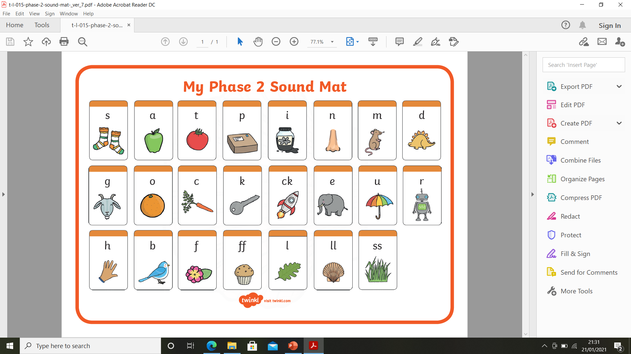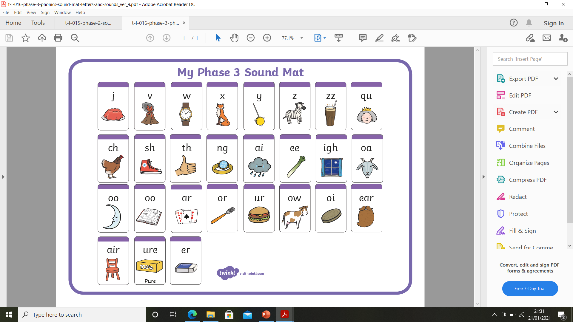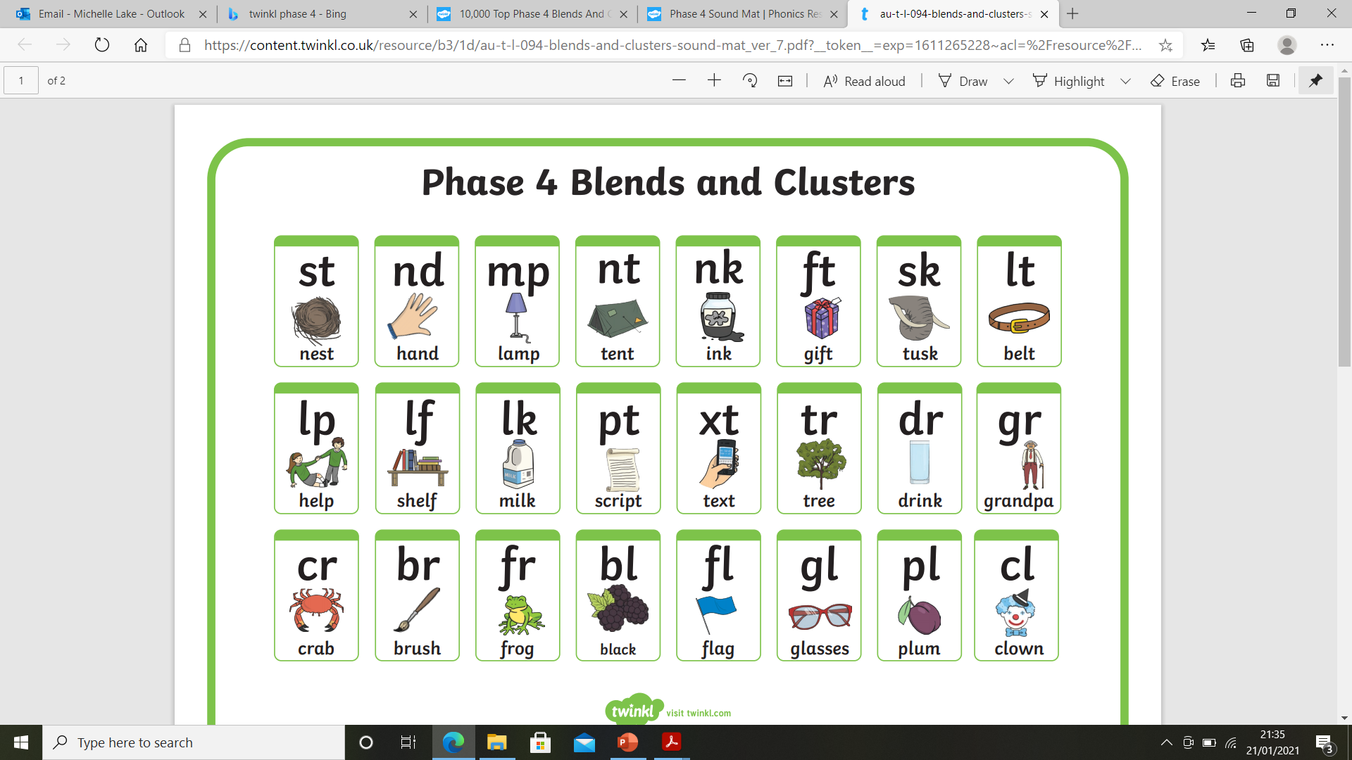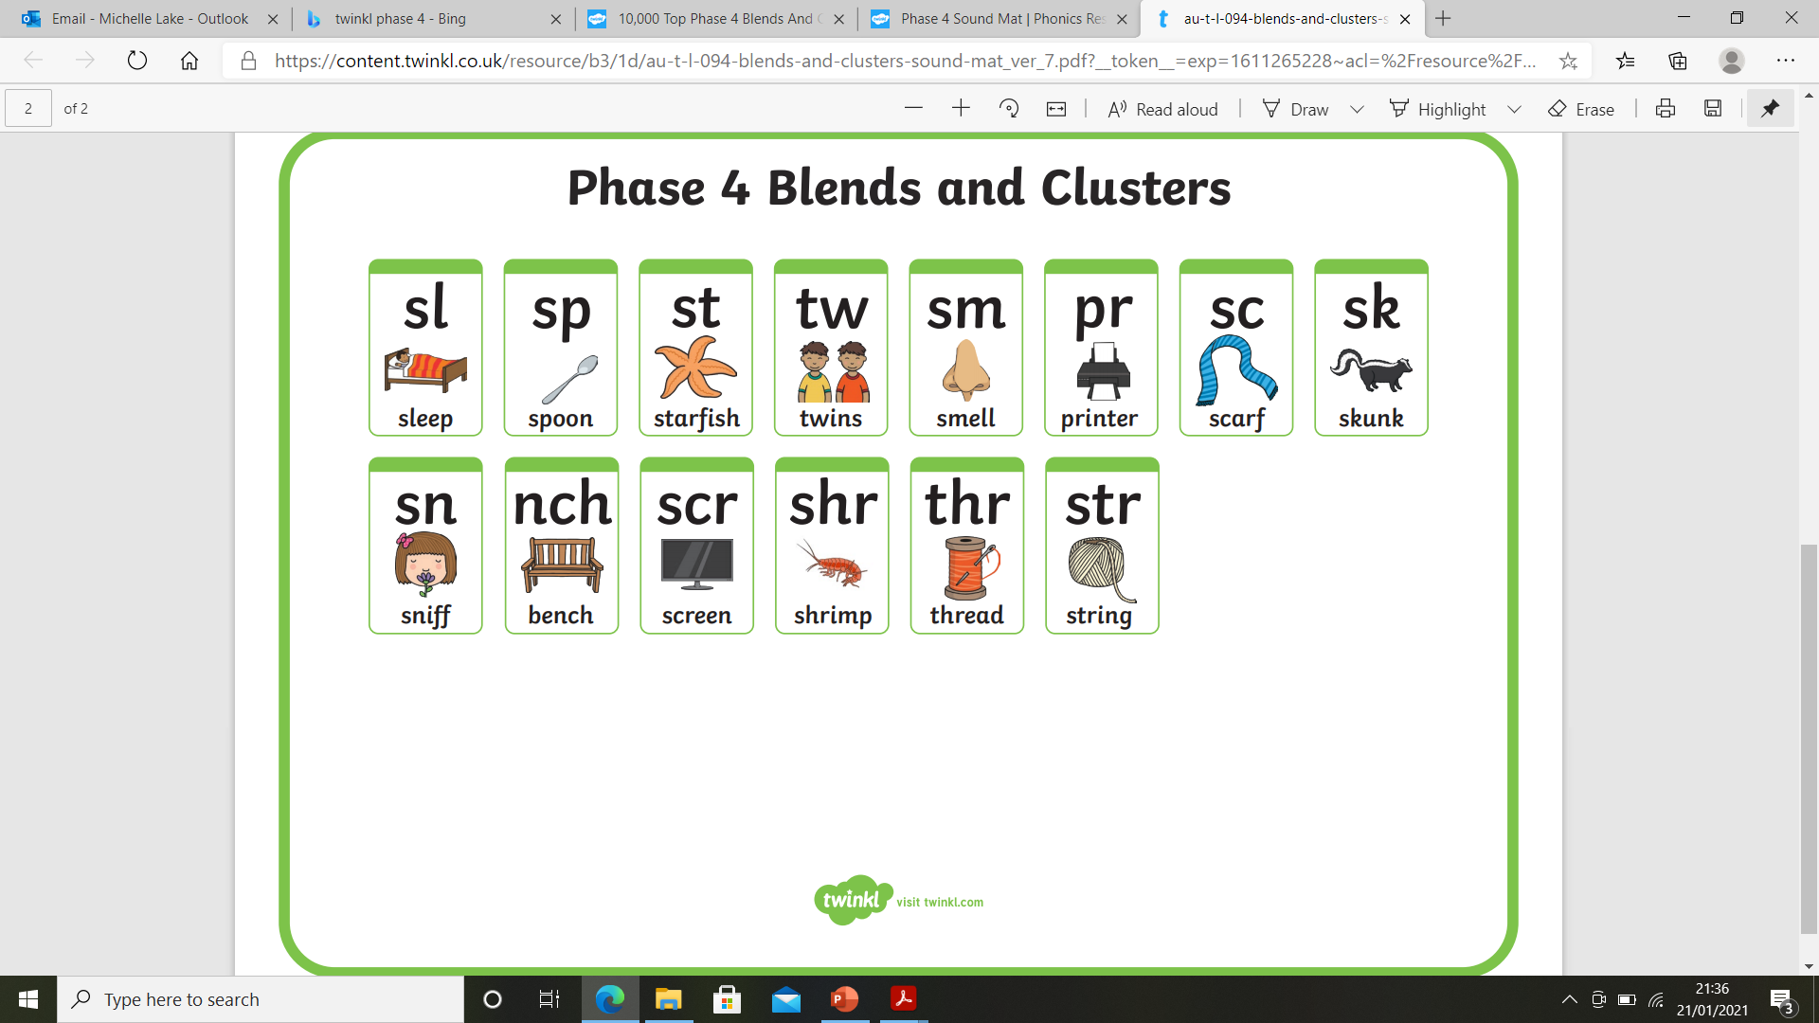 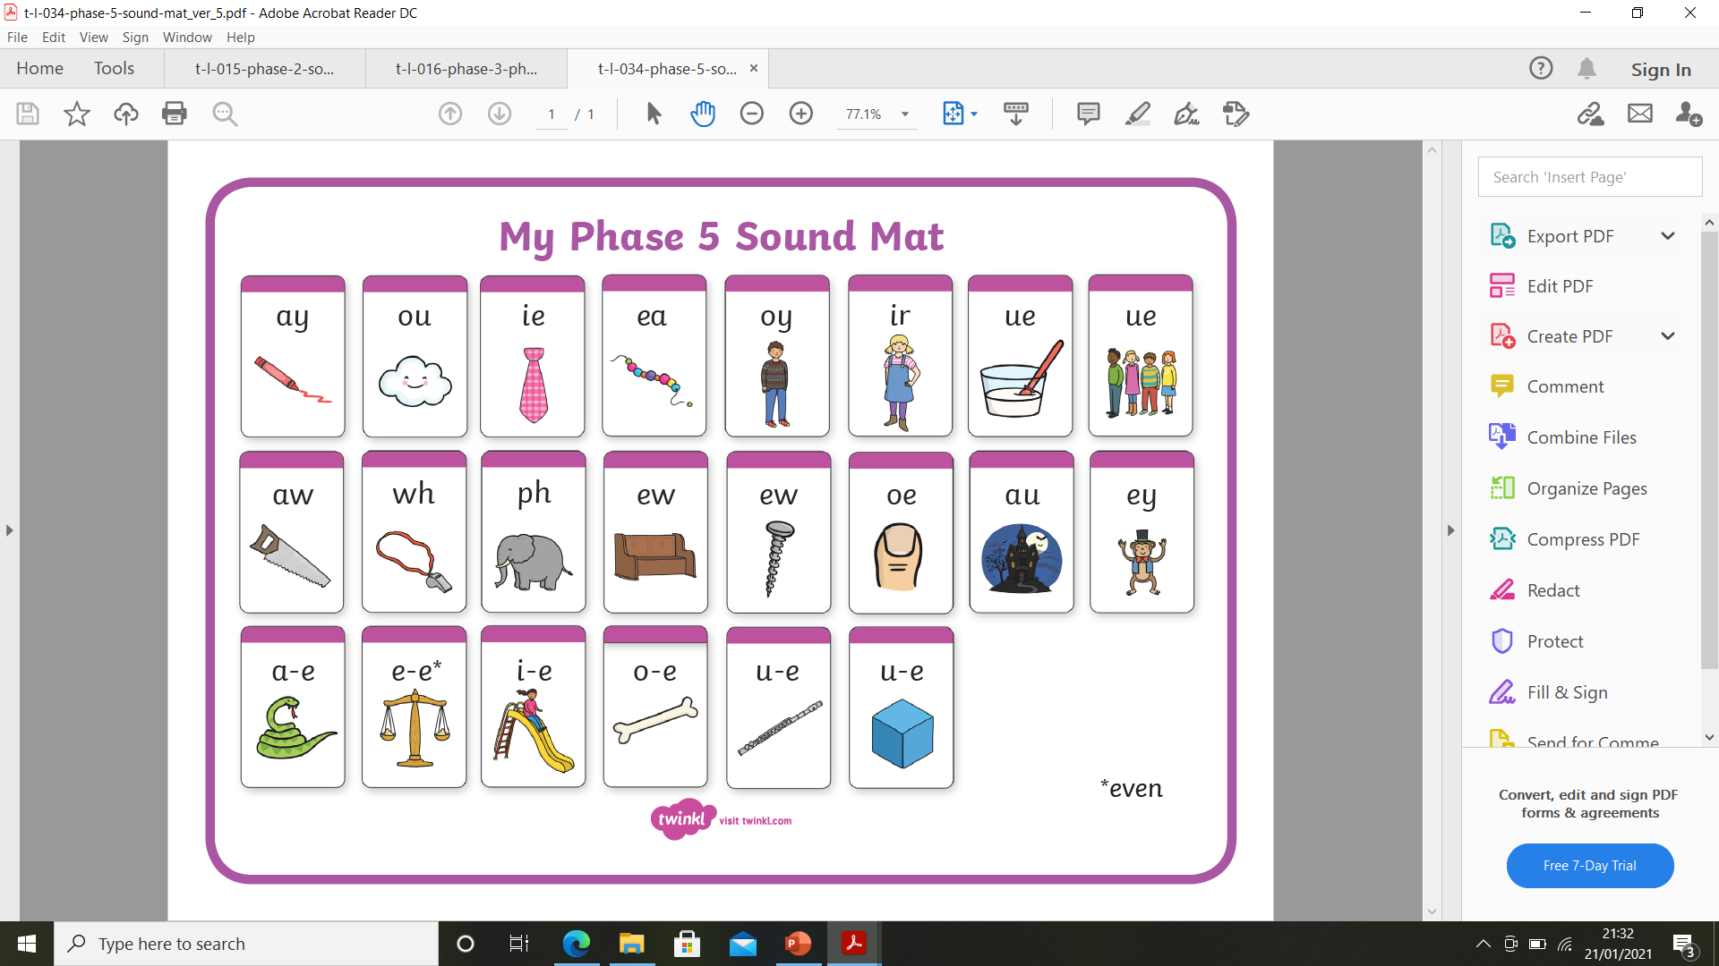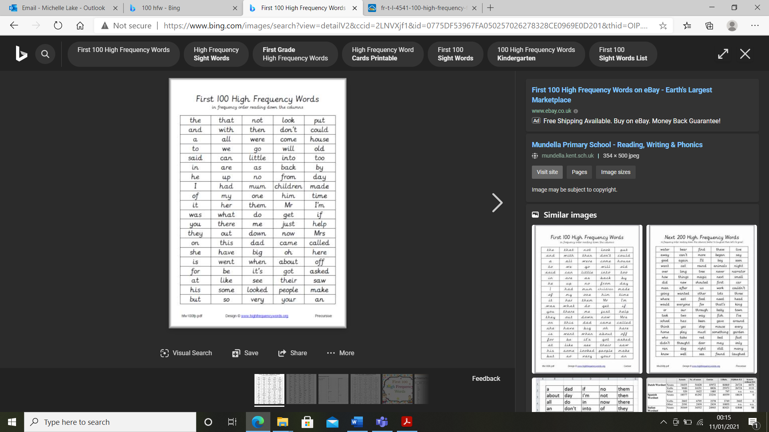

|  |  |  |  |  |  |
| --- | --- | --- | --- | --- | --- |
| Maths | | | | | |
| Monday | Tuesday | Wednesday | Thursday | | Friday |
| Teams session – multiplication assessment  Paper and pen/pencil required  (if you are not able to attend, please watch the recorded session and send a photo of work completed to Dojo) | Teams session – division elicitation assessment  Paper and pen/pencil required  (if you are not able to attend, please watch the recorded session and send a photo of work completed to Dojo) | Count in 2s using lego forwards and backwards 2-20.  Walt: .make equal groups – grouping.  Click on the hyperlink (Ctrl + click twice): [To share a total equally between a set number of groups (thenational.academy)](https://classroom.thenational.academy/lessons/to-share-a-total-equally-between-a-set-number-of-groups-6cu3cd?step=1&activity=video)  Press play and watch the video.  Take part when needed, stop the video to do the activity or repeat.  You will need a pencil/pen and paper, and some counters/cut up pieces of paper or small objects to count with.  Complete the task below: | Count in 2s using fingers forwards and backwards 2-20.  Walt: divide using reasoning and problem solving skills.  Click on the hyperlink (Ctrl + click twice): [To share a total equally and find the number of groups (Part 1) (thenational.academy)](https://classroom.thenational.academy/lessons/to-share-a-total-equally-and-find-the-number-of-groups-part-1-65hkad?step=1&activity=video)  Press play and watch the video.  Take part when needed, stop the video to do the activity or repeat.  You will need a pencil/pen and paper, and some counters/cut up pieces of paper or small objects to count with. | | Count in 2s by saying and fingers forwards and backwards 2-20.  Walt: divide using reasoning and problem solving skills.  Click on the hyperlink (Ctrl + click twice): [To share a total equally and find the number of groups (Part 2) (thenational.academy)](https://classroom.thenational.academy/lessons/to-share-a-total-equally-and-find-the-number-of-groups-part-2-61jp8r?step=1&activity=video)  Press play and watch the video.  Take part when needed, stop the video to do the activity or repeat.  You will need a pencil/pen and paper, and some counters/cut up pieces of paper or small objects to count with. |
| **Wednesdays task:** | | | | **Fridays Task:** | |
| **Thursdays task:** | | | | | |
| Extension task:  Year 1 – [Mathletics United Kingdom | Empowering Maths Learning Online](https://www.mathletics.com/uk/)  Year 2 – [Mathletics United Kingdom | Empowering Maths Learning Online](https://www.mathletics.com/uk/) [Times Tables Rock Stars (ttrockstars.com)](https://ttrockstars.com/)  use your logons | | | | | |

|  |  |  |  |  |
| --- | --- | --- | --- | --- |
| English  Our new unit -Information: all about tigers. | | | | |
| Monday | Tuesday | Wednesday | Thursday | Friday |
| Walt: what do you know about tigers?  Create a poster with:  -a picture of a chosen tiger  -written facts about the tigers -anything else you would like to show that you know about tigers | Walt: listen and respond to an information text.  Click on the hyperlink (Ctrl + click twice): [To listen and respond to an information text (thenational.academy)](https://classroom.thenational.academy/lessons/to-listen-and-respond-to-an-information-text-64r6ae?step=1&activity=video)  Press play and watch the video.  Take part when needed, stop the video to do the activity or repeat.  You will need a pencil/pen and paper. | Walt: tell an information text from memory.  Click on the hyperlink (Ctrl + click twice): [To tell an information text from memory (thenational.academy)](https://classroom.thenational.academy/lessons/to-tell-an-information-text-from-memory-c8wk2t?step=1&activity=video)  Press play and watch the video.  Take part when needed, stop the video to do the activity or repeat.  You will need a pencil/pen and paper. | Walt: deepen an information text through role play.  Click on the hyperlink (Ctrl + click twice): [To deepen an information text through role play (thenational.academy)](https://classroom.thenational.academy/lessons/to-deepen-an-information-text-through-role-play-cgtp6d?step=1&activity=video)  Press play and watch the video.  Take part when needed, stop the video to do the activity or repeat.  You will need a pencil/pen and paper. | Walt: To add 's' to make nouns plural.  Click on the hyperlink (Ctrl + click twice): [To add 's' to make nouns plural (thenational.academy)](https://classroom.thenational.academy/lessons/to-add-s-to-make-nouns-plural-6gu6cr?step=1&activity=video)  Press play and watch the video.  Take part when needed, stop the video to do the activity or repeat.  You will need a pencil/pen and paper. |

|  |  |  |  |
| --- | --- | --- | --- |
| Reading | | | |
| Session 1 | Session 2 | Session 3 | Extension task: |
| Choose a book – online or at home  Focus on reading:  Is it fiction or nonfiction?  Predict what the book is about using the cover and title  Segmenting and blending new words  Reading and remembering familiar words  Sounding out using phonics  Following words with a finger under the word  Following sounds in words by following with finger  Conclude the prediction – was it correct? Why? Why not? how was it the same? How was it different? | Read the same book again as session 1  Focus on:  Summarise the story from yesterday  What happened at the beginning? Middle? End of the story?  Why did …… happen?  Who did…..  Why did …… do…..?  What could happen next?  What might happen after the story finishes? Why do you think that? | Read a different book – from home.  Focus on reading skills:  Skills from session 1 and 2 | Oxford Owl  Here is the login details of my account.  <https://www.oxfordowl.co.uk/>  *Username:* bn class 2   Password: BN class 2  (ensure you leave a space (space bar) between the 3 parts of the username and password)  Please select a book band your child is on. If you are not sure, please dojo me.  Oak Academy virtual free library  [Virtual School Library | Oak Academy (thenational.academy)](https://library.thenational.academy/)  Each week focuses on a different author. There are videos about the author. You can read the author’s book (child and parent together). There are also activities that can be completed linked to the author and book too. |

|  |  |
| --- | --- |
| **Art** | **Walt: make and prints with blocks.**  Make a cardboard block (any design – see photos below but keep it simple). Allow to dry.  Make prints using the block in 1 colour in a line or as repetition of 4 in a square.  Extend to printing using different colours.  Printmaking with Cardboard - ARTBAR |
| **Science** | **Walt: find out what animals need to survive.**  Click on the hyperlink (Ctrl + click twice): [What do animals need to survive? - BBC Bitesize](https://www.bbc.co.uk/bitesize/topics/z6882hv/articles/zx38wmn)  Press play and watch  Take the quiz  Choose an animal at home (plastic, duplo etc). Build a shelter for the animal using junk, lego, loose parts (anything that can be reused and constructed). Provide the animal with food, water and a suitable bed. Send me a photo to see your caring homes. |
| **Geography** | **Walt: identify, locate and name countries in the UK.**  Click on the hyperlink (Ctrl + click twice : [Let's explore the UK - BBC Bitesize](https://www.bbc.co.uk/bitesize/topics/zyhp34j/articles/z4v3jhv)  Press play and watch  Take the quiz  Complete the sheet below: |
| **Mind-**  **Fulness** |  |
| **Pe** | **Walt: move like an animal.**    **Think of other animals and how they move. Practise moving or standing as a statue like different animals.** |