Class 1 Reception children Home Learning activities
Week commencing: Monday 27th April 2020
This week the planning is following on from the Supertato book by Sue Hendra and Paul Linnet. However, we are moving on to looking at superhero’s and designing your own superhero culminating to thinking about our superhero NHS key workers at the end of the week.
Weekly Focus | Activity 1 | Activity 2 | Activity 3 | Activity 4
Maths  Mathematics - Number  - Counts objects to 10 and beginning to count beyond 10 (40-60 months)  - Recognises some numerals of personal significance (40-60 months) | Try to fill in the missing numbers. Can you get an adult to help you go beyond 20? | 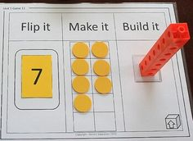  Use numbers up to 20. You can use anything for the make it section– possibly pasta or pennies. You could use Lego or building blocks for the build it section. | 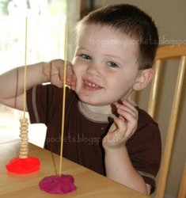  Adults give the children some number cards and get them to count that number of cherrios out and put them on the spaghetti. | Get an adult to write the numbers 0-20 on some paper or card, cut them up and then ask an adult to mix the numbers up – don’t peek! Then, see how quickly you can out them into the correct order. You can ask someone to time you and then see if you can get faster when you try again.
English  Literacy - Writing  - Attempts to write short sentences in meaningful contexts (40-60 months)  - Can segment the sounds in simple words and blend them together (40-60 months)  - Uses some clearly identifiable letters to communicate meaning, representing some sounds correctly and in sequence (40-60 months) | 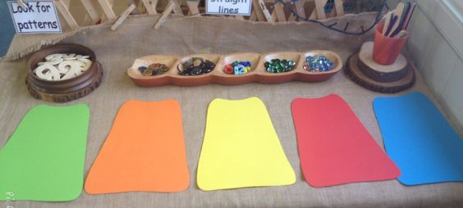  Adult to cut a superhero cape. Can you decorate it to describe your personality? You may decorate using animal’s, a repeating pattern or something of your own choice. | 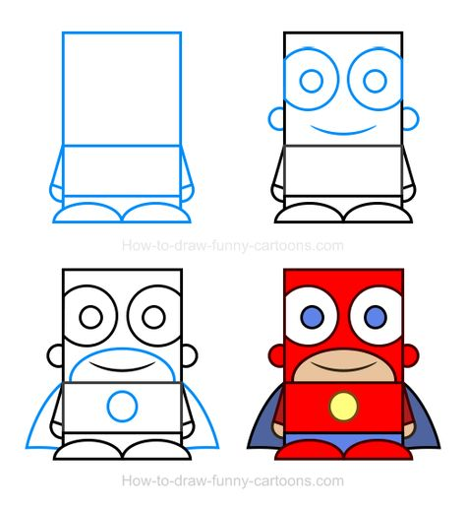  Talk about what your name would be if you were a superhero and what special powers you would have. Draw a picture of your superhero and load it onto Facebook or Class DoJo | Design your own superhero | 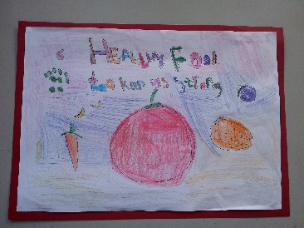  Design and draw a how to stay healthy poster (cover coughs and sneezes, wash hands and eat healthy foods. You may choose to use this opportunity to talk about the corona virus and make your poster more specific for keeping safe during the COVID-19 pandemic – talk about social distancing, good hand washing, staying at home etc.)
Creative  Expressive Arts & Design – Exploring & using media and materials  - Manipulates materials to achieve a planned effect (40-60 months)  - Constructs with a purpose in mind, using a variety of resources (40-60 months) | 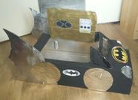  Use building bricks or boxes to make a home or car for Supertato. Think about how tall and wide it will need to be. | Use your handprint to make a superhero. | When making or eating a meal, discuss with an adult which parts of the meal are healthy for your body. Can you make a healthy snack, such as a fruit salad or fruit smoothie and take a photo of it to load onto the class one Facebook page or class dojo message page? | 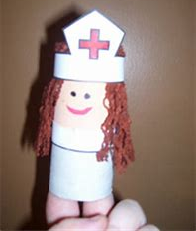  Use a toilet roll to make a superhero NHS nurse or doctor. Can you be really clever and add some PPE to your medic? Take a photo and upload onto our Facebook or Class DoJo page.

For your information, next week the book we will be basing most activities around will be What the Ladybird Heard by Julia Donaldson.

Please contact me via email on mhorrell@exmoorlink.org if you need any further guidance, or if you would like to share your activities online with the rest of our class please visit our private class 1 home learning Facebook page or class DoJo (emails were sent home to invite you to join last week) and upload a photo of you and your child doing the activity.

