Class 1 Reception children Home Learning activities

Week commencing: Monday 15th June 2020

This week the planning is based around the book Princess Mirror-Belle by Julia Donaldson. If you have this book please share it with your child. If not, please click on the following link https://www.youtube.com/watch?v=BYey1fzbIiI where you will be able to read the book with your child. Most of the activities this week are based around Princess Mirror-Belle.

Weekly Focus | Activity 1 | Activity 2 | Activity 3 | Activity 4
Maths | 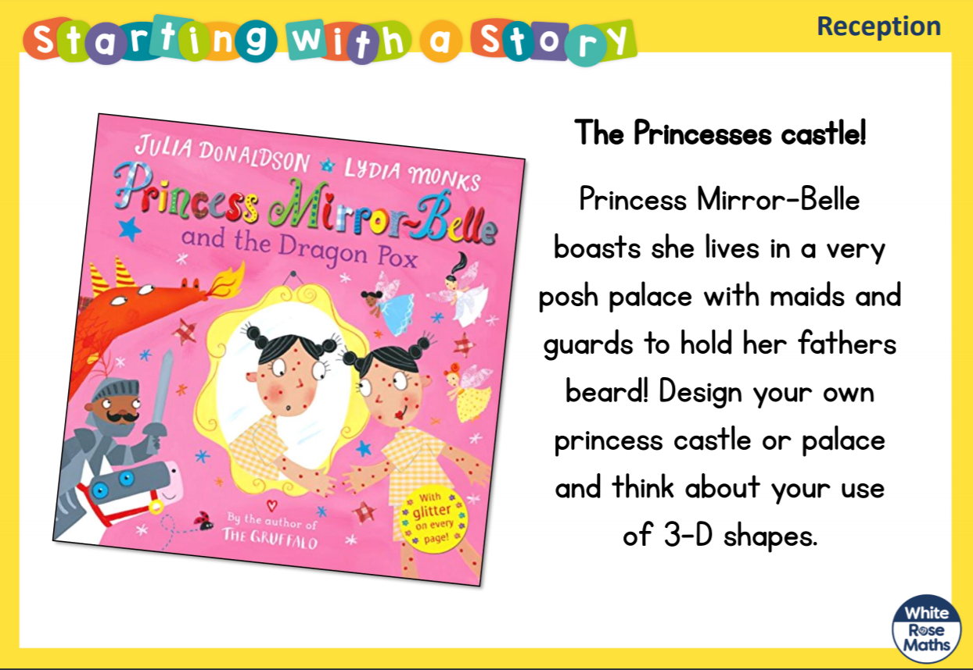  Try to draw a picture of your palace – which shapes will you use? Can you label your drawing to show the shapes that you are planning to use? | 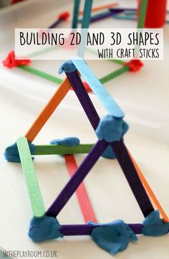  Can you build some 3D shapes using lolly sticks and blue tack, or spaghetti and marshmallows? Which 3D shapes can you make? | Talk about the shapes – can you name them? How many edges, corners, faces does each shape have?
English | 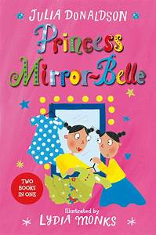  Share this book with your child if you have it at home. If not use the link above to view it on you tube. Enjoy the pictures and get children to predict what might happen next. | Explain that the Magic Mirror allows a person to look at themselves at any time in their life – the past, present or future. Get your child to draw their Magic Mirror picture on a piece of paper. | Ask you child the following questions. Try to get them to expand their answers so that they come up with some good vocabulary ready to write tomorrow.  Who was there? / Who were you with? Where were you? / Where did it happen/take place? When/How long ago was it? / When did it happen/take place? Why were you there? How did you feel? What did you say? What did you do? What were you doing in the picture? | Write what happened in your Magic Mirror – who was in your Magic Mirror? What happened?
Creative | 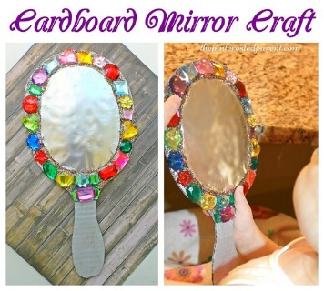  Use an old cardboard box and get an adult to help you cut out a mirror shape. Stick tin foil onto the cardboard to make it look like a mirror. Decorate your mirror. | 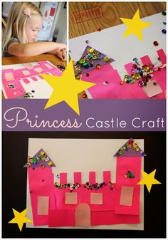  Design a palace either for a princess or a prince – what shapes might you use? | 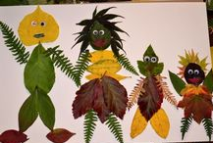  Collect some leaves and try to make a leaf prince or princess. Perhaps you could make a whole leaf family. | 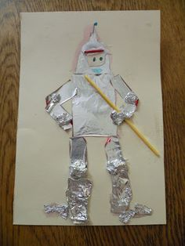  Use tin foil to create a knight to protect the princess in her castle

In addition to the activities above the following websites are really useful if you require additional work
- The Maths Factor | https://www.themathsfactor.com
- Phonics Play | https://phonicsplay.co.uk
- The Oak National Academy | https://www.thenational.academy
- BBC Bitesize | https://www.bbc.co.uk/bitesize
- Twinkl | https://www.twinkl.co.uk/resource/eyfs-school-closure-home-learning-resource-pack-t-tp-2549362
- Oxford Owl | www.oxfordowl.co.uk

Over the next few weeks, I am looking at using TEAMs in order to virtually see and talk to all reception children who are continuing to learn at home. The school office will be emailing permission slips and instructions as to how your child can be a part of this group. Please keep an eye on your email for further information.

Please contact me via email on mhorrell@exmoorlink.org if you need any further guidance.

