Class 1 Nursery Children Home Learning Activities

Week commencing: Monday 13th July 2020

This week the planning is based around the book How many legs? by Kes Gray and Tim Field. If you have this book please share it with your child. If not, please click on the following link https://www.youtube.com/watch?v=gmUY5bXkVKQ where you will be able to read the book with your child. Most of the activities this week are based around the book How many legs?

 | Activity 1 | Activity 2
Maths | 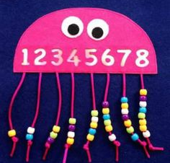  Get your adult to make you an octopus like the picture but use larger numbers from 10-20 and beyond if your child can manage it. Then thread the correct number of beads or Cherrios onto the legs. | 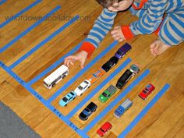  Complete some number sentences using cars and trucks or different coloured cars to show what your number sentence is saying.
English | 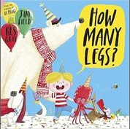  Share this book with your child if you have it at home. If not use the link above to view it on you tube. Enjoy the pictures and get children to begin to retell the story | Get some of your animals from around your home. Retell the story using your animals.
Creative | 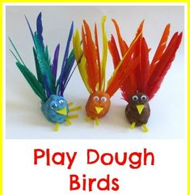  Make some playdough birds. How many legs does a bird have? | Make some hedgehog bread. How many legs does a hedgehog have?

In addition, if your child is due to start school in September, please can you get your child to try doing the following activities
- practise writing their name in a pre-cursive style
- draw attention to signs that they may recognise around them, such as Tesco, Sainsbury, McDonalds etc
- talk about graphemes (letters) that they may see in the environment
- try using their pincer grip (pencil grip) in a variety of situations, such as picking up cherrios from a plate, using a peg to move pom poms from one place to another
- practise counting – count the number of stairs in your house, the number of grapes on your plate etc.
- practising throwing and catching a large ball

Please contact me via email on mhorrell@exmoorlink.org if you need any further guidance.

