Class 1 Nursery Children Home Learning Activities
Week commencing: Monday 1st June 2020

This week the planning is based around the book The Snail and the Whale by Julia Donaldson. If you have this book please share it with your child. If not, please click on the following link https://www.youtube.com/watch?v=hheolVGZVvs where you will be able to read the book with your child. Most of the activities this week are based around The Snail and the Whale.
 | Activity 1 | Activity 2
Maths | 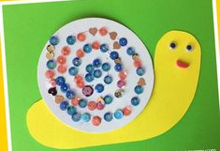  Get your adult to help you cut out a snail shape. Then decorate it using your finger print and 2 colours or using two different colours/objects. See if you can make a repeating pattern. | 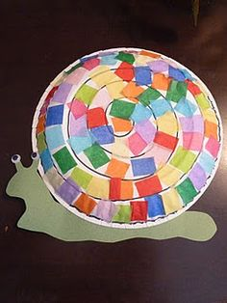  Get your grown up to draw you a snail and help you to think about a repeating pattern. Use some coloured paper and make a repeating pattern on a snail shell.
English | 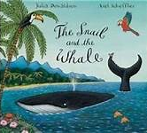  Share this book with your child if you have it at home. If not use the link above to view it on you tube. Enjoy the pictures and get children to predict what might happen next. | 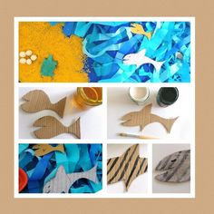  Use am old cardboard box or paper to make the animals in the story snail and a whale. Use these animals to retell the story of Snail and a whale to an audience – you can do this in a socially distanced manner! Remember to rehearse your story lots of times first so that you know the story really well. Perhaps you could ask an adult to film you telling the story and put it on class dojo.
Creative | Find a smooth stone and use paint or felt tip pens to decorate the shell. Can you make a pattern? Ask your grown up to make you some playdough and roll it into a sausage shape to make snail. | 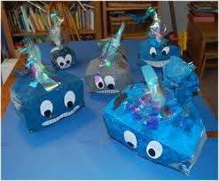  Paint a box blue and decorate to look like a whale – I would love to see some of your super whales on class dojo!

Over the next couple of weeks, I will be communicating with parents during the new class DoJo app – please can you make sure that you have accepted the invitation to your child’s learning so that we can work together to support your child’s learning at home. I love seeing photos of your child completing some of the activities.

Please contact me via email on mhorrell@exmoorlink.org if you need any further guidance.

