Class 1 Reception children Home Learning activities

Week commencing: Monday 29th June 2020

This week the planning is based around the book Oliver’s Vegetables by Vivian French. If you have this book please share it with your child. If not, please click on the following https://www.youtube.com/watch?v=2yvllKqyVUc where you will be able to read the book with your child. Most of the activities this week are based around Oliver’s Vegetables.
Weekly Focus | Activity 1 | Activity 2 | Activity 3 | Activity 4
Maths  Shape space & Measures 40-60 months  - Can describe their relative position such as ‘behind ‘or ‘next to’  Shape space & Measures ELG  - Children use everyday language to talk about size, weight, capacity, position, distance, time and money to compare quantities and objects and to solve problems.  Numbers ELG  - Children count reliably with numbers from one to 20, place them in order and say which number is one more or one less than a given number. Using quantities and objects, they add and subtract two single-digit numbers and count on or back to find the answer. They solve problems, including doubling, halving and sharing | 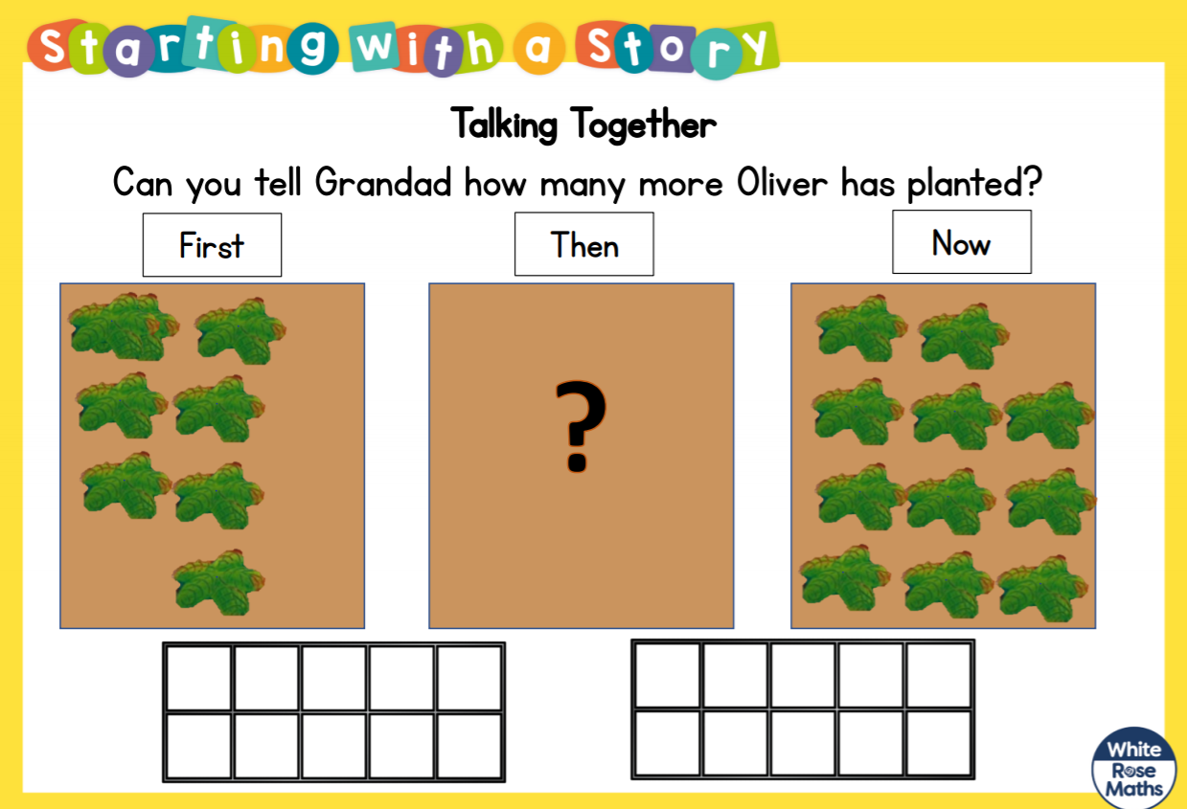 | 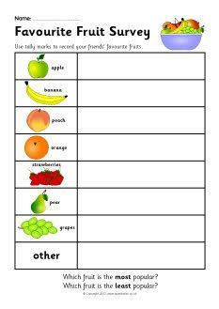  Ask your family and friends (perhaps you could phone them) what their favourite fruit is and complete a tally chart. Which was the favourite fruit? Which was the least favourite fruit? | 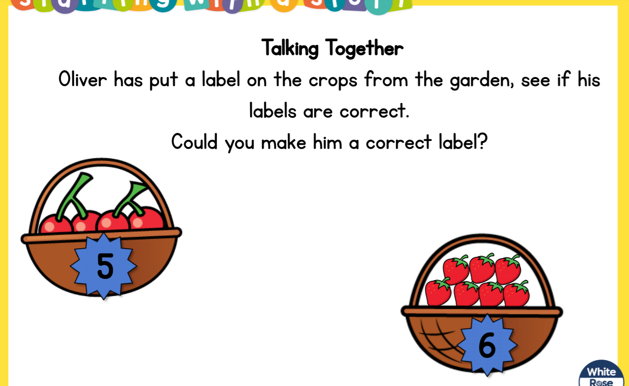  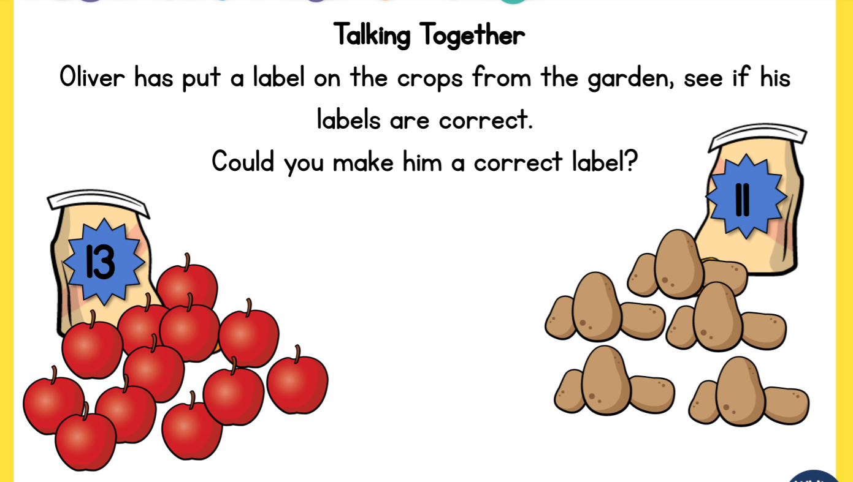  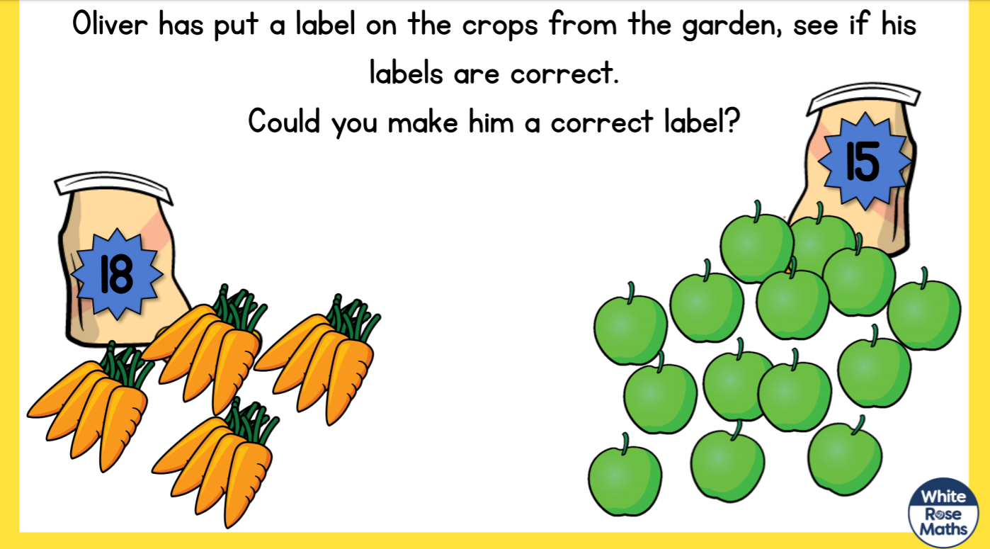
English  Writing ELG  Children can spell phonetically regular words of more than one syllable as well as many irregular but high frequency words. They use key features of narrative in their writing. | 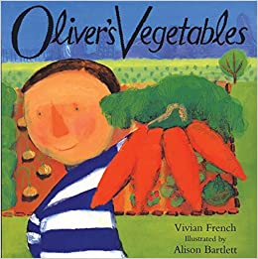  Share this book with your child if you have it at home. If not use the link above to view it on you tube. Enjoy the pictures and get children to predict what might happen next. | Look at the picture and think about some sentences to describe the picture. Can you write some of these sentences down? Can you add any descriptive language, such as “I can see a big, juicy pineapple.” | 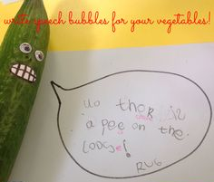  Help your child to write speech bubbles using fruit and vegetables around your home. | Have a go at making Oliver’s soup (see recipe). Then have a go at writing simple instructions about how to make the soup using words such as, first, next, then, finally.
Creative  Being imaginative ELG  Children talk about the ideas and processes which have led them to make music, designs, images or products. They can talk about features of their own and others’ work, recognising the differences between them and the strengths of others. | Healthy food – eat lots of these.  Eat little of these.  Use food items that you have at home and help your child to separate them into healthy items and items to eat a little of. | 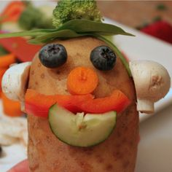  Can you use a potato and fruit and vegetables to make a vegetable person | 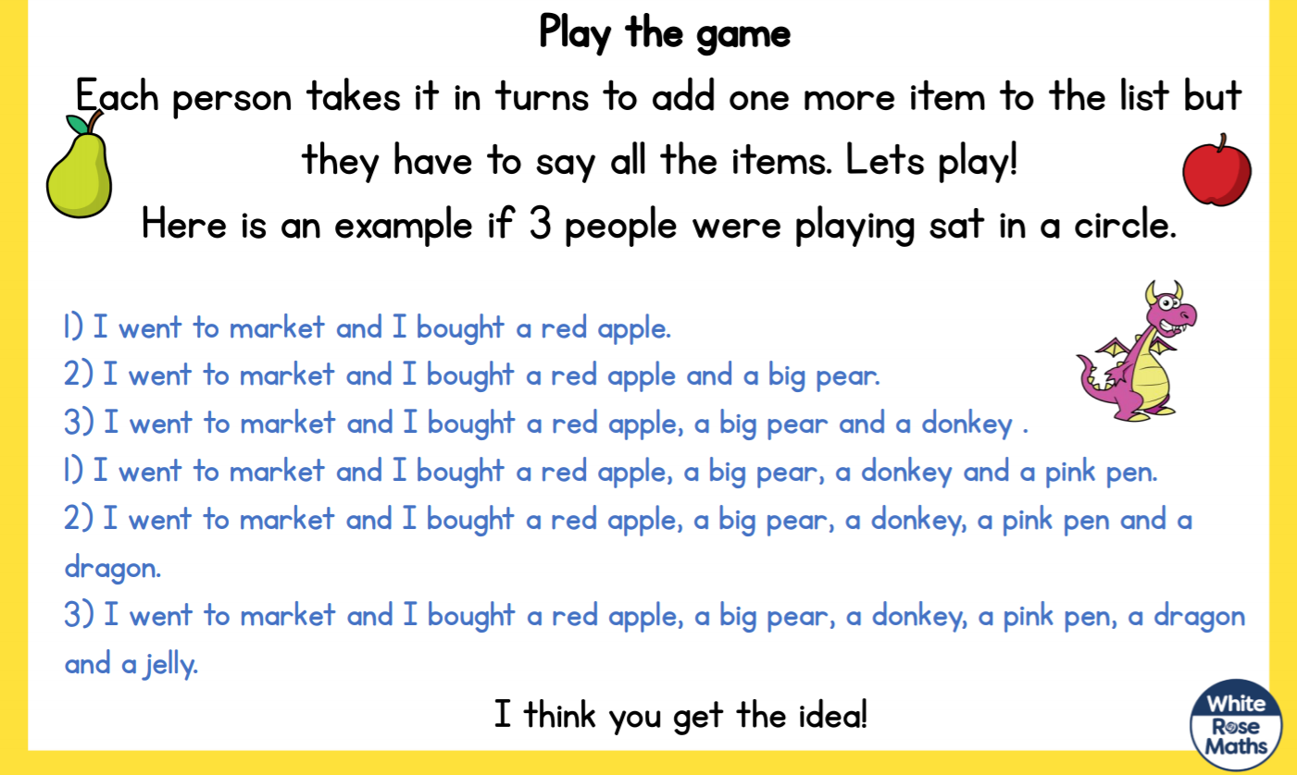  Have a go at playing the above memory game with your family – it is great fun and can be really funny! | 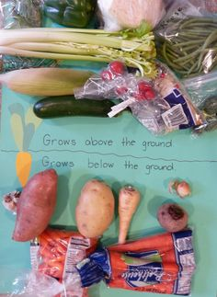  Use some vegetables and with help from your grown up split them into things that grow above the ground and things that grow below the ground.

In addition to the activities above the following websites are really useful if you require additional work

- The Maths Factor | https://www.themathsfactor.com
- Phonics Play | https://phonicsplay.co.uk
- The Oak National Academy | https://www.thenational.academy
- BBC Bitesize | https://www.bbc.co.uk/bitesize
- Twinkl | https://www.twinkl.co.uk/resource/eyfs-school-closure-home-learning-resource-pack-t-tp-2549362
- Oxford Owl | www.oxfordowl.co.uk

Unfortunately, I have been unable to reactivate the class do jo. (I have no idea what I have done!) Class do jo have told me that they have a number of queries and that they will get back to be as soon as they can, but as yet I have still heard nothing. Therefore, please can I ask you to revert back to the Facebook page or contacting me via email. I am sorry for the inconvenience. I have missed seeing all your child’s hard work so it would be lovely to see it again.
Please contact me via email on mhorrell@exmoorlink.org if you need any further guidance.

