Geography. Where I live.
We will be looking at where we live for the next 4 weeks.
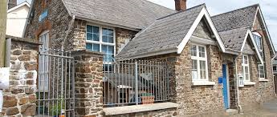
Bishops Nympton Primary School, Bishops Nympton, South Molton, Devon EX36 4PU
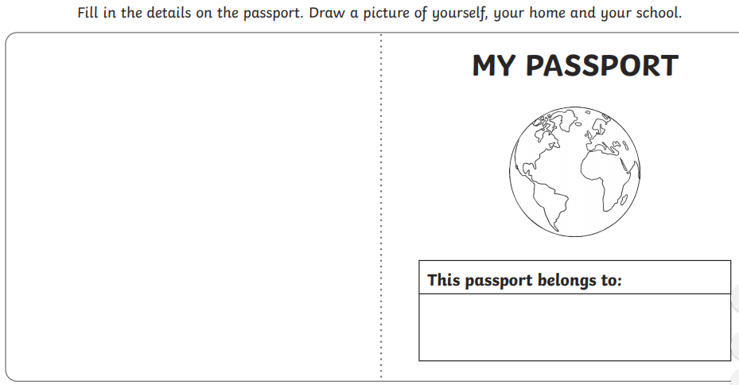

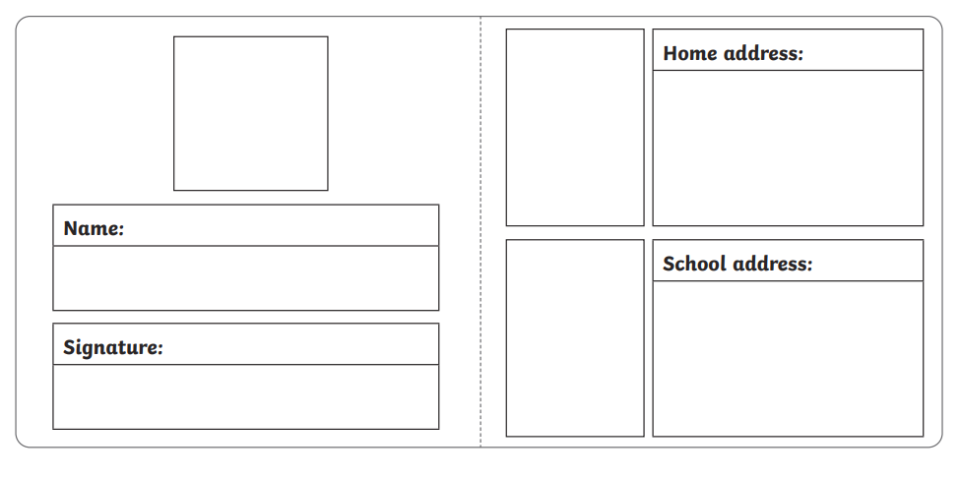

Find Bishops Nympton on the map.

