Class 1 Nursery Children Home Learning Activities
Week commencing: Monday 27th April 2020
This week the planning is following on from the Supertato book by Sue Hendra and Paul Linnet. However, we are moving on to looking at superhero’s and designing your own superhero culminating to thinking about our superhero NHS key workers at the end of the week.
 | Activity 1 | Activity 2
Maths  Mathematics – Number  - Number - Recites numbers in order to 10 (30-50 months)  - Recognises some numerals of personal significance (40-60 months) | 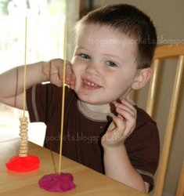  Adults give the children some number cards and get them to count that number of cherrios out and put them on the spaghetti. | Get an adult to write the numbers 0-10 and beyond if appropriate, on some paper or card, cut them up and then ask an adult to mix the numbers up – don’t peek! Then, can out them into the correct order.
English  Literacy – Writing  - Sometimes gives meanings to marks as they draw and paint (30-50 months) | 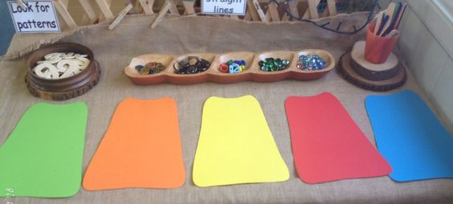  Adult to cut a superhero cape. Can you decorate it to describe your personality? You may decorate using animals, a repeating pattern or something of your own choice. | 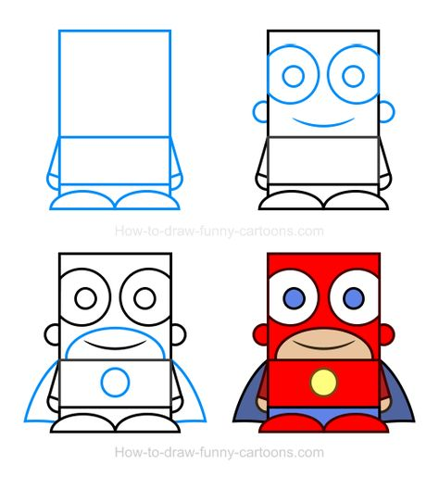  Talk about what your name would be if you were a superhero and what special powers you would have. Draw a picture of your superhero and load it onto Facebook or Class DoJo
Creative  Expressive Arts & Design – Exploring Using media and materials  - Manipulates materials to achieve a planned effect (40-60 months)  - Uses various construction materials (30-50 months) | 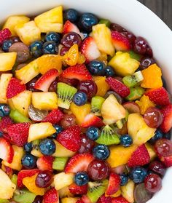  Can you make a healthy snack, such as a fruit salad or fruit smoothie and take a photo of it to load onto the class one Facebook page or class dojo message page? | 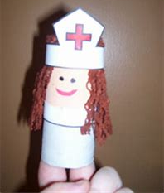  Use a toilet roll to make a superhero NHS nurse or doctor. Can you be really clever and add some PPE to your medic? Take a photo and upload onto our Facebook or Class DoJo page.

For your information, next week the book we will be basing most activities around will be What the Ladybird Heard by Julia Donaldson.

Please contact me via email on mhorrell@exmoorlink.org if you need any further guidance, or if you would like to share your activities online with the rest of our class please visit our private class 1 home learning Facebook page or class DoJo (emails were sent home to invite you to join last week) and upload a photo of you and your child doing the activity.

