WALT : Use basic geographical vocabulary.
Mark where the following might be on your map of the county of Devon.
- beach, town,
- cliff, farm
- coast, village
- forest, house,
- hill, sea,
- river, harbour
- shop

Somerset
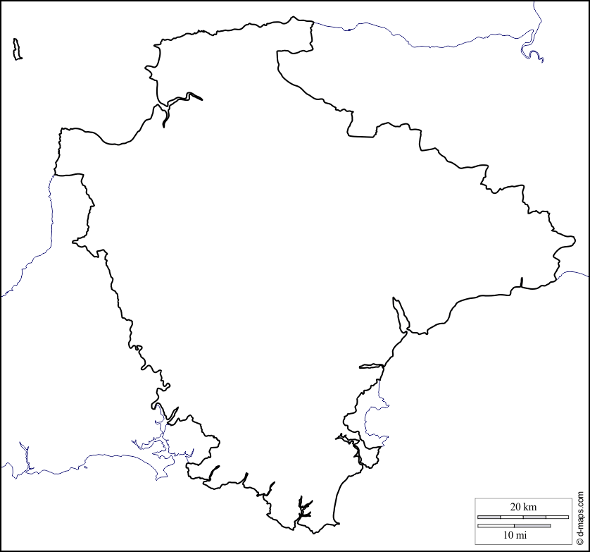
Cornwall

