WALT: To identify and sort animals that are herbivores, carnivores and omnivores.
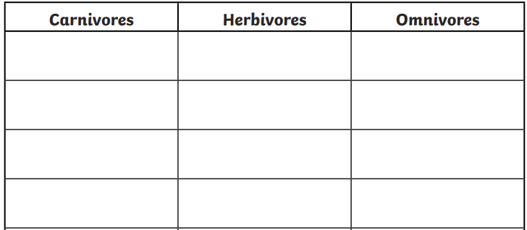
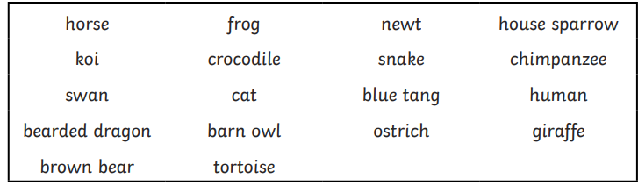

Scientific reasoning:
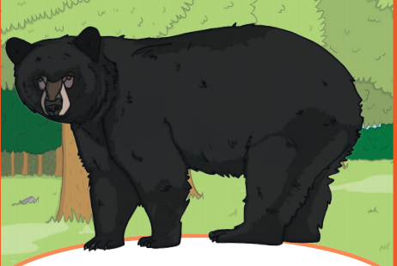
What food do you think this animal eats?

What does an omnivore eat?

What does a carnivore eat?

What does a herbivore eat?

