**Year 1 Class 2 - Week 6 planning W/C 8.2.2021**

This pack includes remote home learning for class 2 – year 1.

Please use the planning for your child’s correct age group, unless told otherwise. If your child finishes and finds the task easy, then please move onto the extension tasks only.

This pack provides a full week’s worth of work, we will be using the pack in school too.

Please complete the following tasks this week (this is the minimum required amount of work that should be completed this week):

* Three reading tasks
* Three English writing tasks
* Two handwriting tasks
* Three phonics tasks
* Four maths tasks
* One science learning activity
* Three non-core sessions eg art, geography
* Physical activities

(This is the minimum amount of work that should be required to complete each week, however you can do the full weeks’ worth of work if you would like).

Spring 1 handwriting

please write in cursive writing on lined paper (please write in cursive, we have come a long way since September)

a b c d e f g h i j k l m n o p q r s t u v w x y z

This is how we write cursive writing on the line. Start on the line, lead up into letters.

This is how we write our letters.

A B C D E F G H I J K L M N O P Q R S T U V W X Y Z

ascenders = b d h t for eg descenders = g q f y for eg

cew = common exception rules (different rules to spelling)

Year 1 write in cursive writing not joined, year 2 joined cursive writing

|  |  |  |  |  |
| --- | --- | --- | --- | --- |
| Handwriting | | | | |
| Monday | Tuesday | Wednesday | Thursday | Friday |
| Focus: spell cew  Words:  gold hold told every great break steak | Focus: spell cew  Words:  pretty beautiful after fast last past father | Focus: spell cew  Words:  class grass pass plant path bath hour | Focus: spell cew  Words:  Move prove improve sure sugar eye could | Focus: spell cew  Words:  should would who whole any many clothes |

Daily videos will be uploaded to Class Dojo and Teams.

|  |  |  |  |  |  |  |
| --- | --- | --- | --- | --- | --- | --- |
| Phonics  Gpc/grapheme = drawn picture of a phoneme eg a b c /digraph eg ai ee /trigraph eg ear ure  phoneme = 1 sound eg a b c digraph = 2 letters make 1 sound eg ai ee trigraph = 3 letters make 1 sound eg ear ure  split diagraph = say letter name eg a o but not the e sound eg a_e | | | | | | |
|  | Monday | Tuesday | Wednesday | | Thursday | Friday (teams session) |
| Review | Recap phase 2 and 3 and 5 (so far) GPCs using flash cards – my turn your turn (quick read)  Recap phase 2 and 3 letter names using flash cards – my turn your turn (quick read)  Recap blends and clusters phase 4 using flash cards – my turn, your turn (quick read)  Read tricky words: oh their people Mr Mrs looked called asked – my turn, your turn (quick read)  Read 10 words from the year1 cew– my turn your turn (quick read) (choose different words each day) | | | | | |
| Teach | Write and read the grapheme ey  Say digraph ey– 2 letters make 1 sound  Write diagraph ey in the air, on the floor, on your hand, on paper/board in cursive | Write and read the grapheme i_e  Say digraph i_e– 2 letters make 1 sound, split diagraph (say letter name i but not the e sound)  Write diagraph i_e in the air, on the floor, on your hand, on paper/board in cursive | Write and read the tricky words:   |  | | --- | | some, come, were, there. |   Write tricky words on the floor, on your hand, on paper/board in cursive | | Write and read the grapheme o_e  Say digraph o_e – 2 letters make 1 sound, split diagraph (say letter name o but not the e sound)  Write diagraph o_e in the air, on the floor, on your hand, on paper/board in cursive | Write and read the grapheme aw  Say digraph a_e– 2 letters make 1 sound, split diagraph (say letter name a but not the e sound)  Write diagraph a_e in the air, on the floor, on your hand, on paper/board in cursive |
| Practise | Write the following words on paper and hide around a room. Read the word and child to read and find the word asked for.  Words:   |  | | --- | | donkey, jockey, turkey, trolley, tronkey, surkey, strolley, quockey. |  |  | | --- | |  | | Write the following words on paper and place on the floor. Parent to read the word by sound talking it and child throws a beanbag, ball etc on to the word.  Write the following words on paper and place on the floor. Child to read the word by sound talking it and child throws a beanbag, ball etc on to the word.  Words:  shine, slide, prize, nice, inside, invite. | Write the tricky words with water and a paintbrush on the floor, wall etc.  Write the tricky words with chalk dipped in water on the floor, wall etc. | | Play picnic on pluto  Click on the hyperlink (Ctrl + click twice): [Picnic on Pluto (phonicsplay.co.uk)](https://www.phonicsplay.co.uk/resources/phase/2/picnic-on-pluto)  Click start, click phase 5, click o_e and start the game | Play hangman  Play bingo  Words:   |  | | --- | | shake, inflape, invade, plame, trake, amaze. | |
| Apply | |  | | --- | | Hold up sentence. Ask children to read aloud and figure out the sentence together. **Can a slide shine all the time? Is it time to get my nice prize yet? Can a jockey win on a donkey? Will a girl put a trolley in a turkey?** | | | Play bingo with these tricky words | | Write the sentence: It w**ill amaze me if you can escape from this maze.** | |
| Extension tasks:  [www.phonicsplay.co.uk](http://www.phonicsplay.co.uk)  Year 1 – phase 2, 3, 4, 5. Year 2 – phase 5 and 6.  Username: jan21 Password: home  Choose any game you like. | | | | Extension tasks:  [Teach Your Monster to Read: Free Phonics & Reading Game](https://www.teachyourmonstertoread.com/)  Set up an account and you are good to go | | |

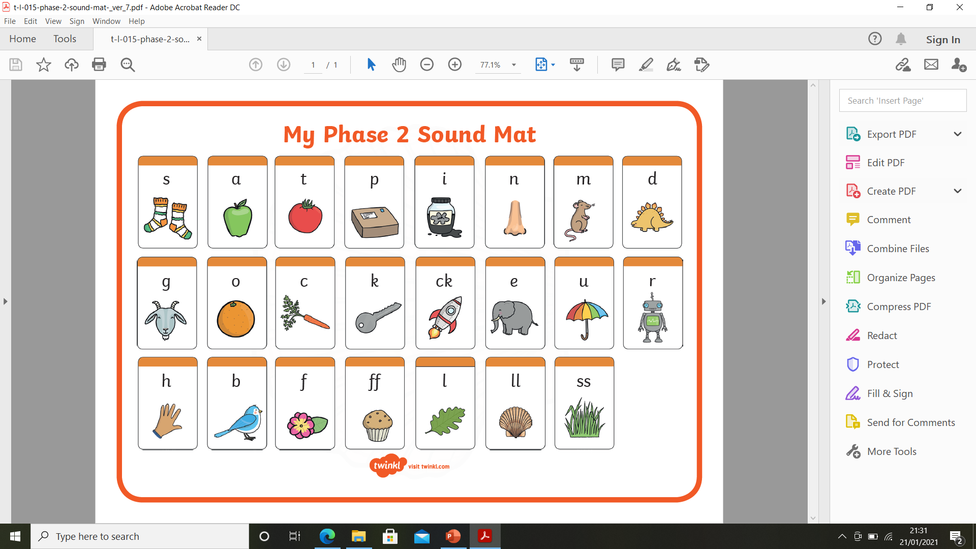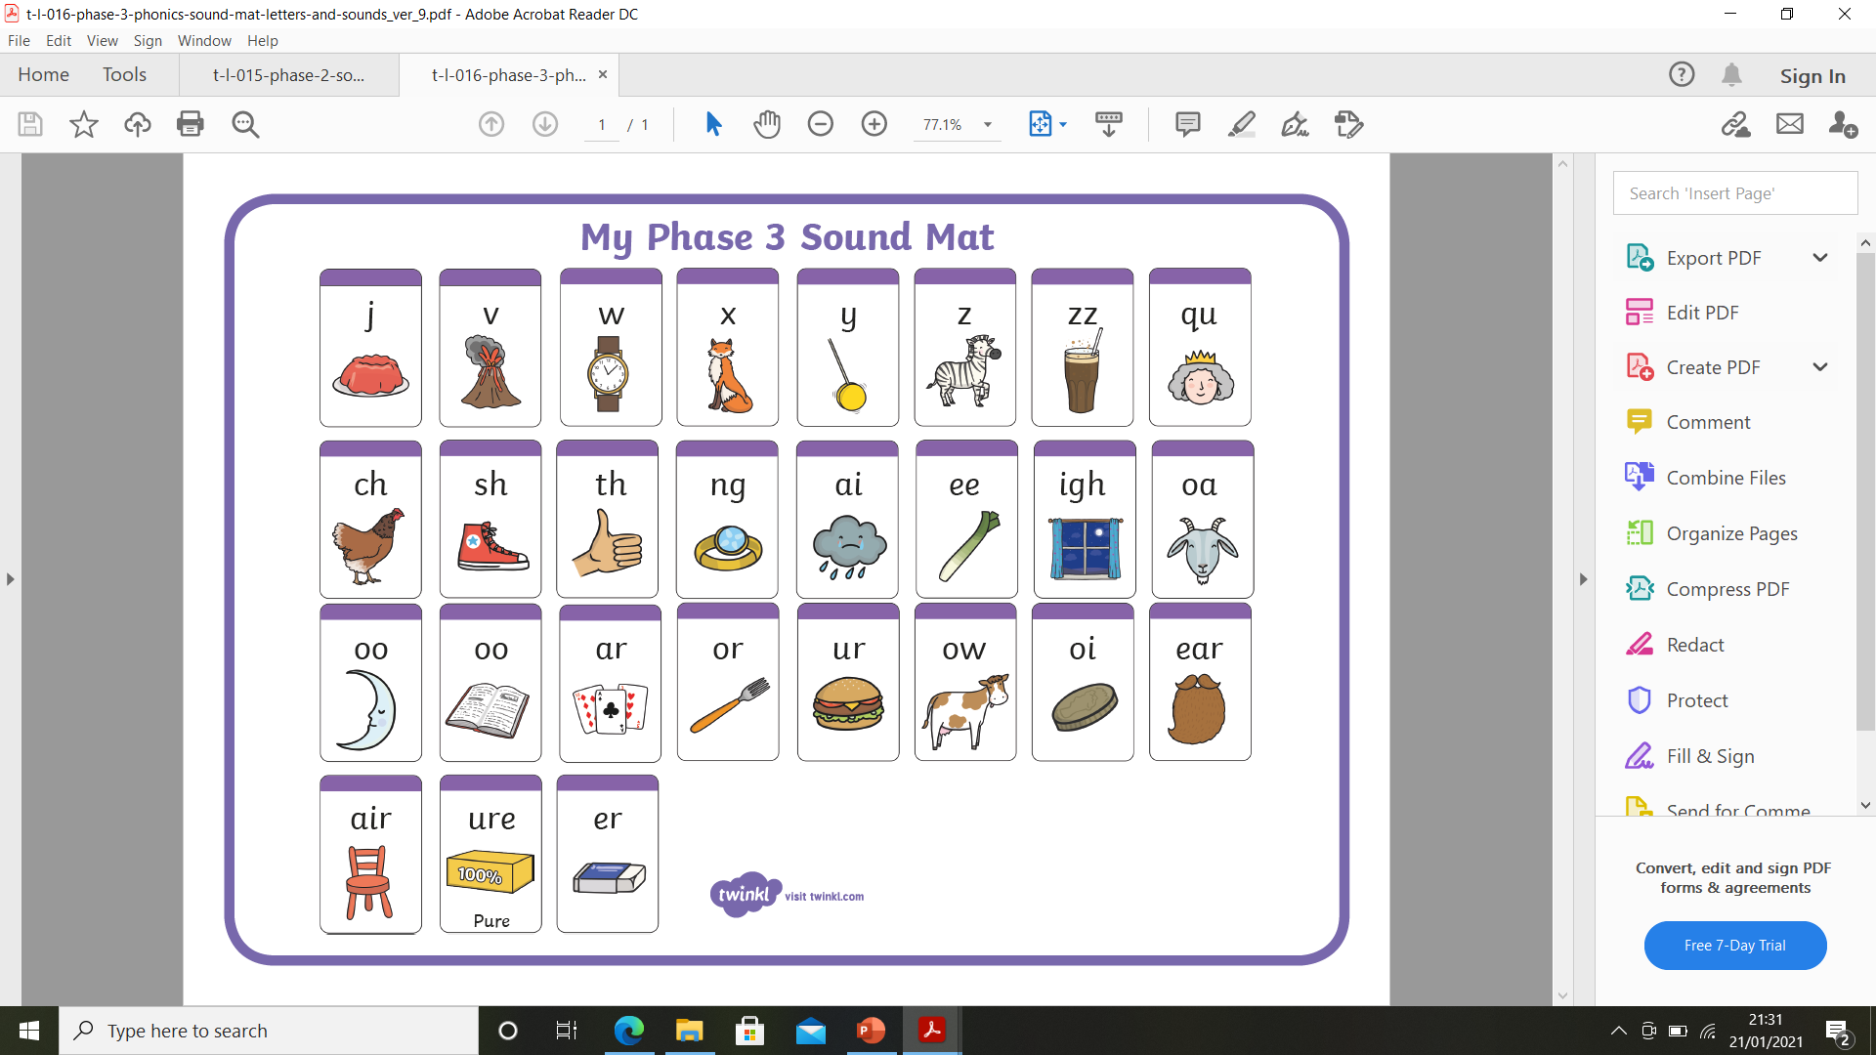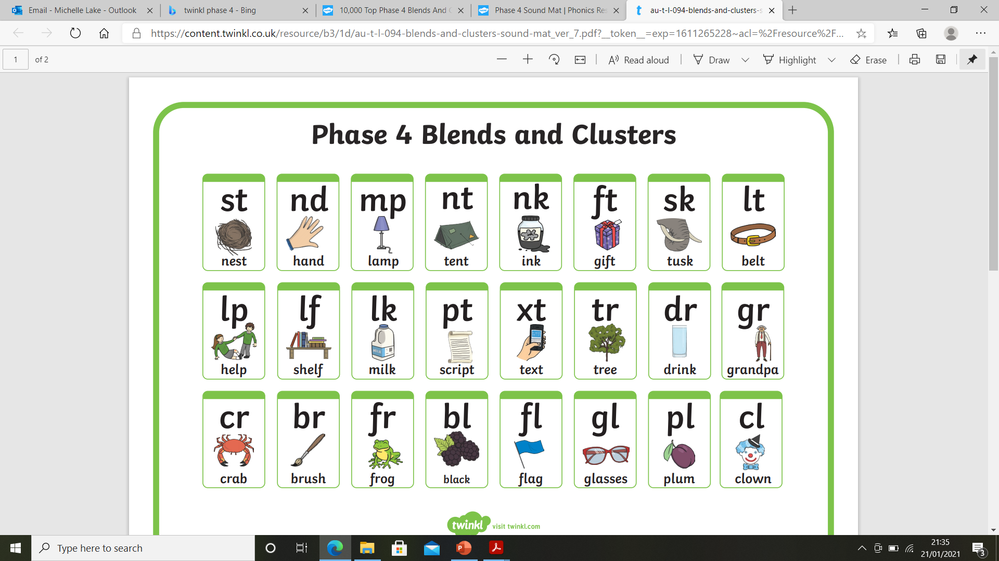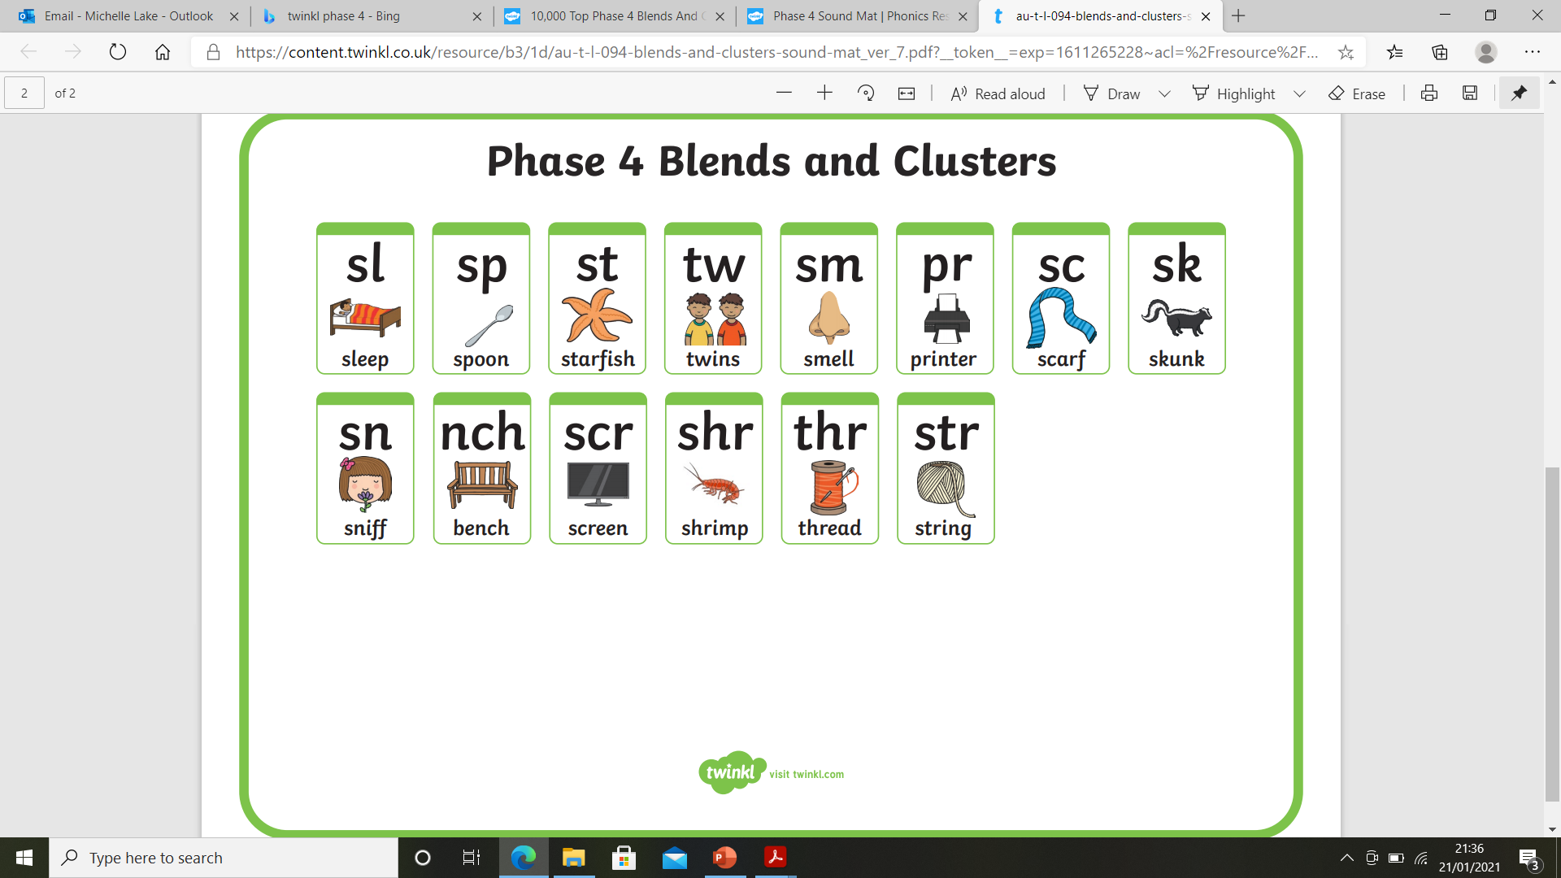 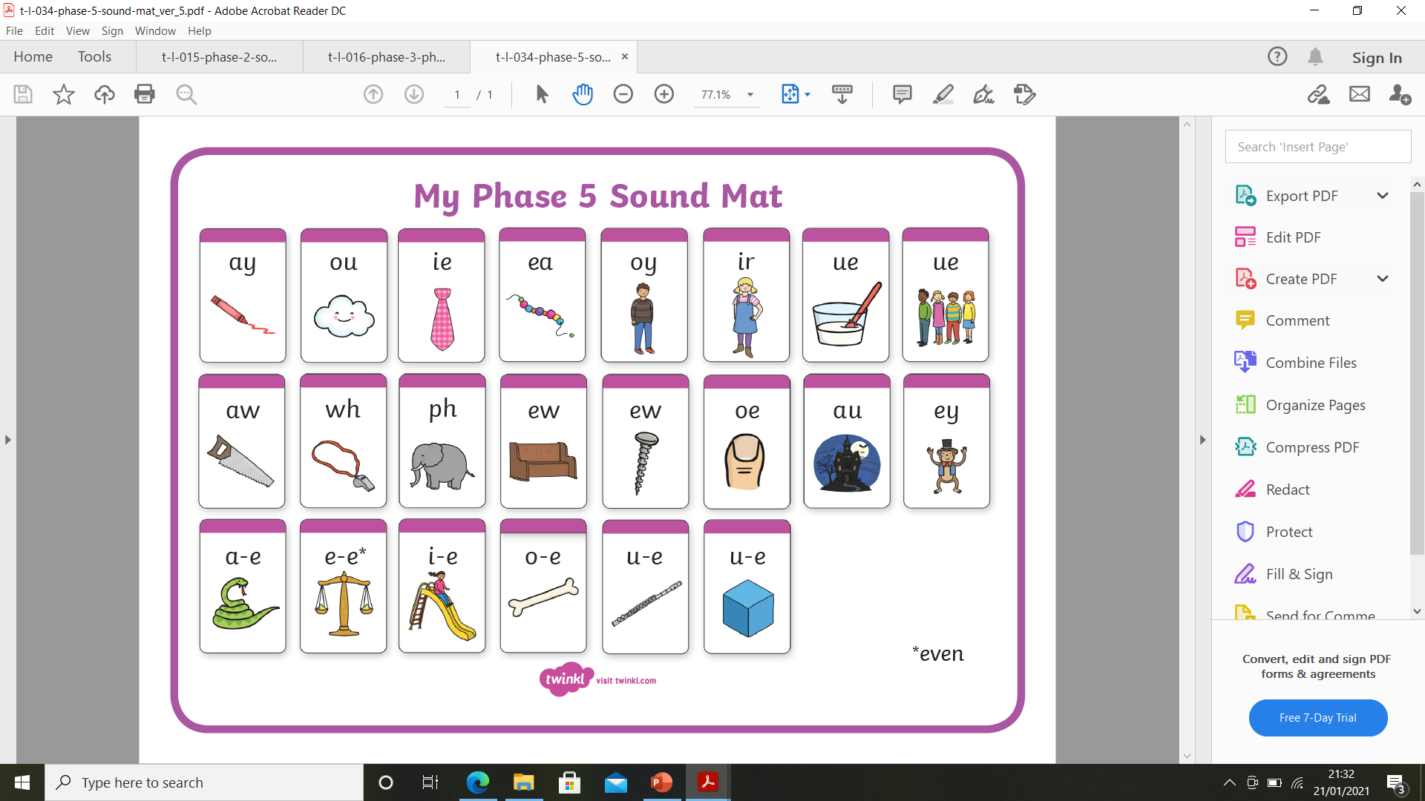

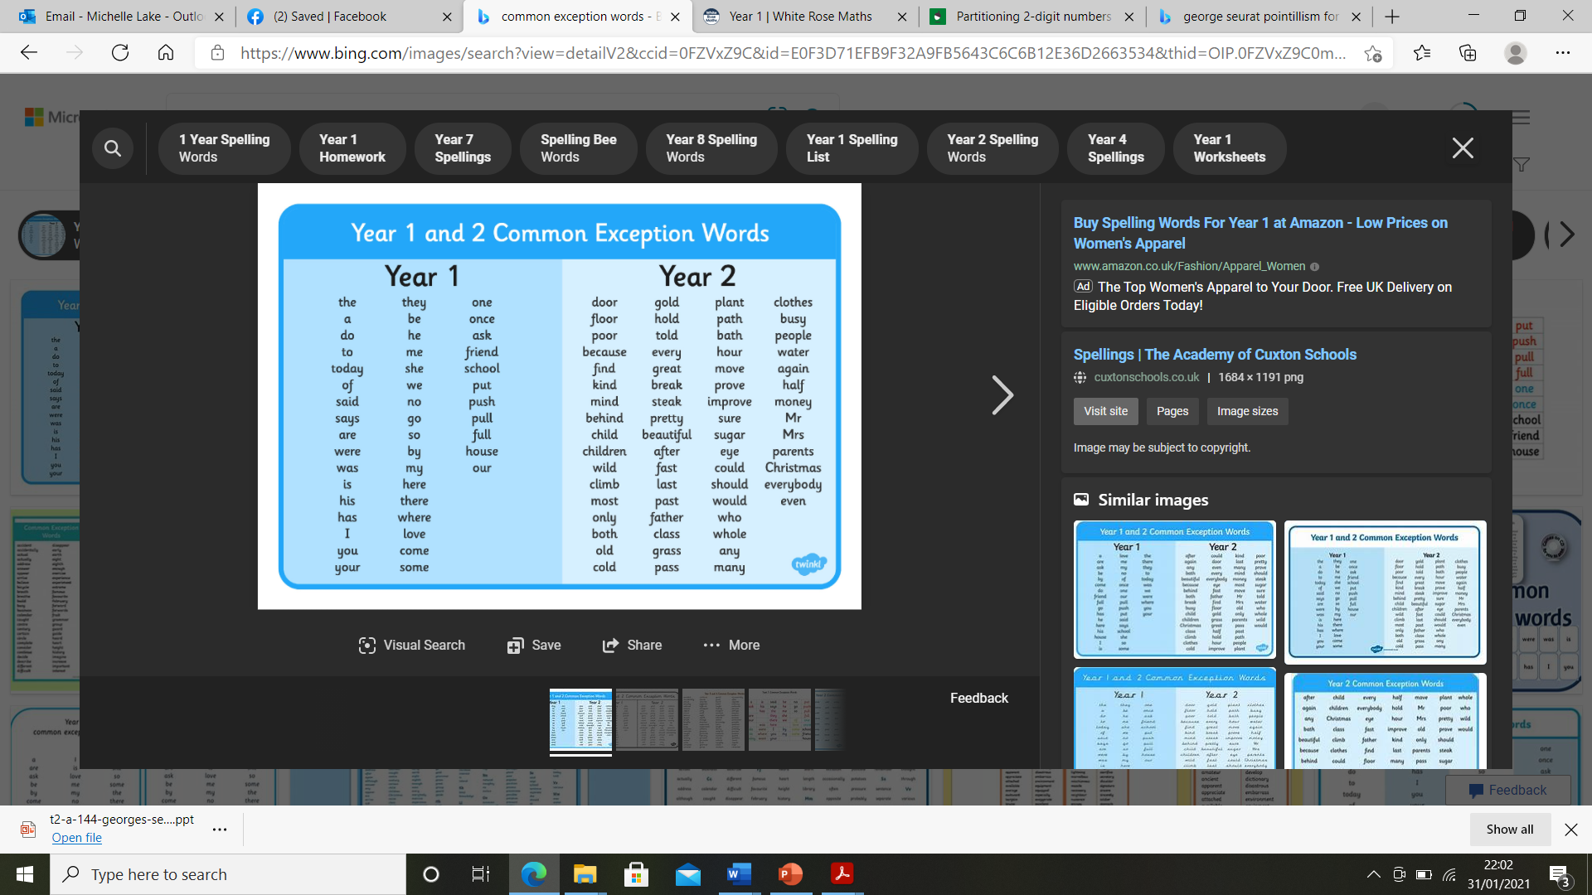

|  |  |  |  |
| --- | --- | --- | --- |
| Maths | | | |
| Monday | Tuesday | Wednesday | Thursday and Friday |
| Make odd amounts from 1-21 using numberals and amounts of objects eg cars, pasta  Walt: comparing numbers to 100.  Click on the hyperlink (Ctrl + click twice)  [To compare numbers within 100 on a number line (thenational.academy)](https://classroom.thenational.academy/lessons/to-compare-numbers-within-100-on-a-number-line-60wpcd?activity=video&step=2&view=1)  [To compare numbers within 100 on a place value chart (thenational.academy)](https://classroom.thenational.academy/lessons/to-compare-numbers-within-100-on-a-place-value-chart-6mrp6r?activity=video&step=2&view=1)  Press play and watch the video.  Take part when needed.  Complete the task below: | Say and show odd numbers on your fingers from 1-21  Walt: ordering numbers.  Click on the hyperlink (Ctrl + click twice)  [To order numbers within 100 (Part 1) (thenational.academy)](https://classroom.thenational.academy/lessons/to-order-numbers-within-100-part-1-65jkat?activity=video&step=2&view=1)  [To order numbers within 100 (Part 2) (thenational.academy)](https://classroom.thenational.academy/lessons/to-order-numbers-within-100-part-2-6nk64d?activity=video&step=2&view=1)  Press play and watch the video.  Take part when needed.  Complete the task below: | Make even amounts from 0-20 using numberals and amounts of objects eg cars, pasta  Walt: 1 more 1 less, 10 more 10 less than a number.  Click on the hyperlink (Ctrl + click twice) [To find one more or one less and ten more or ten less (thenational.academy)](https://classroom.thenational.academy/lessons/to-find-one-more-or-one-less-and-ten-more-or-ten-less-ccvk6c?activity=video&step=2&view=1)  Press play and watch the video.  Take part when needed.  Complete the task below: | Say and show even numbers on your fingers from 0-20  Walt: use non-standard units to measure length (eg hands, cubes, cars) and standard units to measure length (eg rulers).  Click on the hyperlink (Ctrl + click twice): [Using standard and non-standard units when measuring (thenational.academy)](https://classroom.thenational.academy/lessons/using-standard-and-non-standard-units-when-measuring-cnh3jr?step=1&activity=video)  Press play and watch the video.  Take part when needed, stop the video to do the activity or repeat.  Complete the task below: |
| **Mondays Task:** | | | |
| **Tuesday Task:** | | | |
| **Wednesdays task:**    Manipulatives = cars, pasta, buttons – items you can count with | | | |
| **Thursdays and Fridays Task:**   |  |  |  |  | | --- | --- | --- | --- | | Using your hands in a line, measure the length of a:  -television  -door  Draw and write the length using pictures and numbers | Using pasta in a line, measure the length of a:  -book  -pencil  Draw and write the length using pictures and numbers | Using paperclips or lego in a line, measure the length of a:  -banana  -pencil  Draw and write the length using pictures and numbers | Using a ruler, measure the length of a:  -book  -apple  -lego  -small teddy  Draw and write the length using pictures and numbers and in cm | | | | |
| Extension task:  Year 1 – [Mathletics United Kingdom | Empowering Maths Learning Online](https://www.mathletics.com/uk/)  Year 2 – [Mathletics United Kingdom | Empowering Maths Learning Online](https://www.mathletics.com/uk/) [Times Tables Rock Stars (ttrockstars.com)](https://ttrockstars.com/)  use your logons | | | |

|  |  |  |  |  |
| --- | --- | --- | --- | --- |
| English  Our new unit -Information: all about tigers extending into our own chosen animal. | | | | |
| Monday | Tuesday | Wednesday | Thursday | Friday |
| Walt: write an information text  Click on the hyperlink (Ctrl + click twice): [To write an information text (Part 3) (thenational.academy)](https://classroom.thenational.academy/lessons/to-write-an-information-text-part-3-6mu32d?step=1&activity=video)  Press play and watch the video.  Take part when needed, stop the video to do the activity or repeat. | **Ensure you have chosen an animal to research before this session**  Walt: invent planning and box up my own writing.  Team session – will be a modelling session, and you might want to do the actual boxing up of information afterwards. | Walt: write my own invent information text about my own chosen animal.  Using the research and box up invent plan, write the information text about your animal. Use the same format like in the videos and box up plan previously to help.  When completed, go over your work and check for:  Capital letters  Full stops  Finger spaces  Spellings  Nouns  Used the words greatest, smallest, newest, oldest | | |
| Extension tasks:  Click on the hyperlink: [Vocab Ninja Mini Games (vocabularyninja.co.uk)](https://games.vocabularyninja.co.uk/?fbclid=IwAR3MqxBIGCA8_YeHO0rFiEd2zgixMMZKkql-83Guxa8uSYeR86uh2rOASOs)  This is a free website you can play grammar and vocabulary games (the children have not yet learnt all these grammar terms yet though). | | | | |

|  |  |  |  |
| --- | --- | --- | --- |
| Reading (continued – to do at home) | | | |
| Session 1 | Session 2 | Session 3 | Extension task: |
| Choose a book – online or at home  Focus on reading:  Is it fiction or nonfiction?  Predict what the book is about using the cover and title  Segmenting and blending new words  Reading and remembering familiar words  Sounding out using phonics  Following words with a finger under the word  Following sounds in words by following with finger  Conclude the prediction – was it correct? Why? Why not? how was it the same? How was it different? | Read the same book again as session 1  Focus on:  Summarise the story from yesterday  What happened at the beginning? Middle? End of the story?  Why did …… happen?  Who did…..  Why did …… do…..?  What could happen next?  What might happen after the story finishes? Why do you think that?  Where the scene set to? how does the reader feel?  Sequenced what has happened already | Read a different book – from home.  Focus on reading skills:  Can you find the word….?  Can you find me a word that means……? Eg pretty – beautiful  What does the word….. mean?  Teach vocabulary meanings of unfamiliar words  Teach about punctuation . ! “” , ?  Read a sentence and say it in different voices eg sad, happy, cross etc and choose which emotion/voice is best | Oxford Owl  Here is the login details of my account.  <https://www.oxfordowl.co.uk/>  *Username:* bn class 2   Password: BN class 2  (ensure you leave a space (space bar) between the 3 parts of the username and password)  Please select a book band your child is on. If you are not sure, please dojo me.  Oak Academy virtual free library  [Virtual School Library | Oak Academy (thenational.academy)](https://library.thenational.academy/)  Each week focuses on a different author. There are videos about the author. You can read the author’s book (child and parent together). There are also activities that can be completed linked to the author and book too. |

|  |  |
| --- | --- |
| **Research**  **Science**  **Ict**  **English** | **Walt: research about our own chosen animal.**  Choose an animal for English of your choice. Search for (using helpful websites below) and find facts about your animal. You can use books or the internet to help find your facts.  [Animal facts for kids | National Geographic Kids (natgeokids.com)](https://www.natgeokids.com/uk/category/discover/animals/)  [Fun Animal Facts for Kids - Crazy, Cool, Funny, Amazing, Interesting (sciencekids.co.nz)](https://www.sciencekids.co.nz/sciencefacts/animals.html)  [Wiki Facts for Kids (kiddle.co)](https://kids.kiddle.co/Wiki) is a safe search engine for children to use (with adults still) to search for animal facts  **You will need this information before you can do your Tuesdays English session on teams with Mrs Lake.** |
| **RE**  **History**  **-Chinese New Year** | **Walt: learn about and celebrate Chinese New Year.**  This year is the celebration of the ox.  Watch the video:[Chinese and Lunar New Year - CBeebies - BBC](https://www.bbc.co.uk/cbeebies/watch/chinese-new-year) (Click on the hyperlink (Ctrl + click twice) and press play).  Activities you could do and make to celebrate Chinese New Year: |
| **Pshe – valentines day** | **Walt: identify and celebrate everyone unique.**  Watch the video: [What is Valentine's Day and how did it start? - CBBC Newsround](https://www.bbc.co.uk/newsround/16945378) (Click on the hyperlink (Ctrl + click twice) and press play).  Show everyone love this week, especially on Valentines Day.  Draw and cut out hearts. Identify and write something someone does that really touches your heart and you are thankful for eg cooking tea, cooking, washing, playing with you, reading you a story, singing a song to you.  Thank you for cooking my tea  Thank you for making me smile. |
| **History** | **Walt: compare cars from the past to the present day.**  Look at the powerpoint.  Label the diagram below. |
| **Pe** | Have a look at the website: [Cosmic Kids Yoga - YouTube](https://www.youtube.com/user/CosmicKidsYoga) (Click on the hyperlink (Ctrl + click twice) and press play).  Choose a video you like and have ago. It is good fun, but make sure you have plenty of space! |