Class 1 Nursery Children Home Learning Activities
Week commencing: Monday 8th June 2020

This week the planning is based around the book The Princess and the Wizard by Julia Donaldson. If you have this book please share it with your child. If not, please click on the following link https://www.youtube.com/watch?v=XyMw-j5Fmnc where you will be able to read the book with your child. Most of the activities this week are based around The Princess and the Wizard.

 | Activity 1 | Activity 2
Maths | 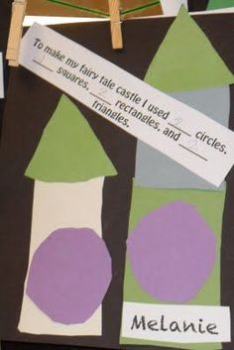 | Walk around your house and make a list of all the different shapes you can see – i.e. rectangle – television, microwave door, table top etc.
English | 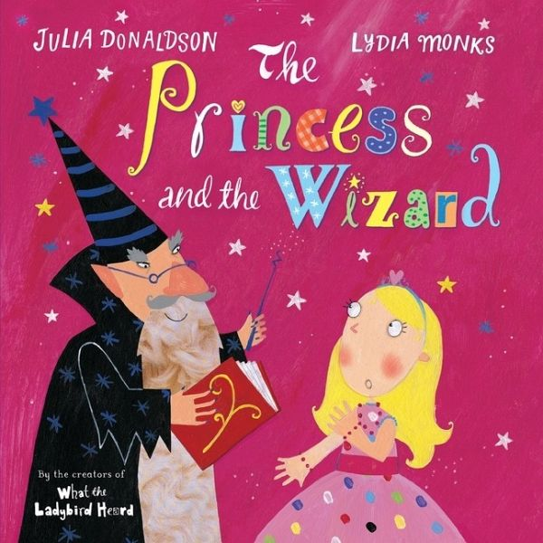  Share this book with your child if you have it at home. If not use the link above to view it on you tube. Enjoy the pictures and get children to predict what might happen next. | Draw a princess and a wizard and retell the story using the characters you have drawn to help you.
Creative | 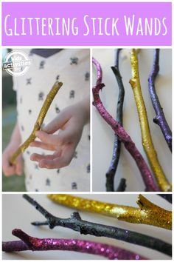  Find a stick to decorate either using paint and/or glitter. You could use this stick to retell the story. | 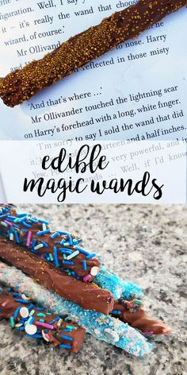  Make some edible magic wands.  - Get some breadsticks.  - Melt some chocolate and then decorate using hundreds and thousands.  - Let your edible wand harden  Enjoy eating your edible wand!

Over the next couple of weeks, I will be communicating with parents during the new class DoJo app – please can you make sure that you have accepted the invitation to your child’s learning so that we can work together to support your child’s learning at home. I love seeing photos of your child completing some of the activities.

Please contact me via email on mhorrell@exmoorlink.org if you need any further guidance.

