Class 1 Reception children Home Learning activities
Week commencing: Tuesday 14th April 2020
Please contact me via email on mhorrell@exmoorlink.org if you need any further guidance, or if you would like to share your activities online with the rest of our class please visit our private class 1 home learning Facebook page and upload a photo of you and your child doing the activity.
 | Weekly Focus | Activity 1 | Activity 2 | Activity 3 | Activity 4
Maths  Mathematics - Shape, Space & Measure (Money)  - Beginning to use everday language related to mone (40-60 months) |  |  | 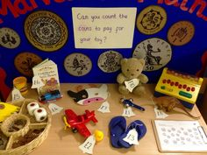  Label some toys/objects around the house with price tags up to 20p and get your child to use real money to ‘buy’ some of the items. | 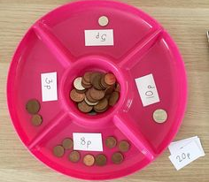  Get children to use real money to make different amounts up to 10p, then 15p, then 20p and beyond if appropriate. | Complete the ‘how much does the ice cream cone cost?’ sheet. Choose the sheet that you feel is appropriate for your child.
English  Literacy - Writing  - Continues a rhyming string (40-60 months) |  |  | 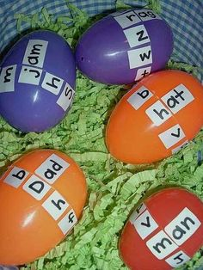  If you have any Easter eggs left over, use them to write some words on as pictured above. Encourage your child to notice the pattern with words that rhyme. | 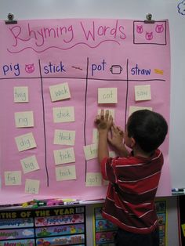  Use the words on the sheet and get your child to write a list of words that rhyme. | 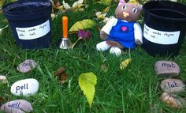  Write some three strings of rhyming words and get your child to organise them into piles/columns/rows of rhyming words. E.g. Mat, hat, sat, fat etc….
Creative  Expressive Arts & Design – Being Imaginative  - Chooses particular colours for a purpose (40-60 months) |  |  | Either use a paper plate or a cut a semi-circle and use paint to create a rainbow. If your feeling clever try and mix the colours. If you don’t have any paint use felt tips, coloured paper or pencils | 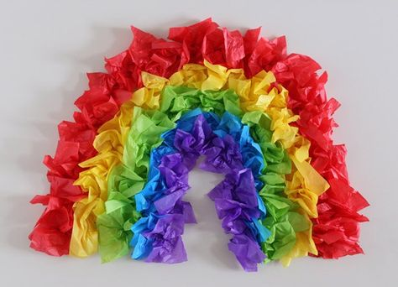  Make a rainbow using tissue paper | Make some Rainbow cookies  (see recipe). Get children to weigh ingredients and talk about what and how they have made it.

Rainbow Chocolate Chip Cookies
- Author: Cookies & Cups
- Prep Time: 15 mins
- Cook Time: 9 mins
- Total Time: 24 mins
- Yield: 36 cookies 1x
- Category: Cookies
- Method: Baking
- Cuisine: Dessert
★★★★★ 4.5 from 4 reviews

Description:
Rainbow Chocolate Chip Cookies are thick and soft rainbow cookies, that just happen to be some of the best chocolate chip cookies ever!

Ingredients:
- 1 cup butter, room temperature
- 1 cup granulated sugar
- 1/2 cup light brown sugar
- 2 teaspoons vanilla
- 2 eggs
- 1 teaspoon kosher salt
- 1 teaspoon baking soda
- 3 cups flour
- 2 cups chocolate chips
- 4 different colors food coloring.

Instructions:
- Preheat the oven to 350°F. Line a baking sheet with parchment paper and set aside.
- In the bowl of your stand mixer fitted with the paddle attachment mix the butter and both sugars together for 2 minutes on medium speed until light and fluffy. Add in the egg, vanilla, salt, and baking soda and continue mixing for 1 minute until smooth, scraping the sides of the bowl as necessary.
- Turn the mixer to low and add in the flour, mixing until just incorporated.
- Stir in the chocolate chips evenly.
- Divide the cookie dough into 4 equal portions. Using the food coloring, color the doughs as desired.
- Roll each colored dough into approximately a 15-inch rope.Place each colored rope next to each other on a large piece of cling wrap. Wrap the cling wrap up tightly, pressing the doughs together forming a large log. Remove the cling wrap and breaking off the dough with your hands into approximately 2-tablespoon portions. Roll the dough into a loose ball and place it onto the prepared baking sheet and bake for 9 minutes or until the edges are set. Don’t over bake these!!
- Allow the cookies to cool on the baking sheet for 3-4 minutes and then transfer to a wire rack to cool completely.

Notes:
Careful to not over bake these. There is a slightly larger amount of flour in these to ensure thickness, but if you bake them too long, they will get very firm. The cookies might even seem under-baked when you remove them from the oven. This is fine.
Place a few extra chocolate chips on top of the dough, if desired, just to look pretty.

