Class 1 Nursery Children Home Learning Activities
Week commencing: Monday 4th May 2020
This week the planning is based around the book What the Ladybird Heard by Julia Donaldson. If you have this book please share it with your child. If not, an electronic copy is available using the following link, https://www.youtube.com/watch?v=Eu9mPX7DuLA where you will be able to read the book with your child. Most of the activities this week are based around the book What the Ladybird Heard.
 | Activity 1 | Activity 2
Maths  Mathematics – Number  - Uses some number names and number language spontaneously. (30-50 months)  - Knows that numbers identify how many objects are in a set. (30-50 months) | Children to make a ladybird with a number of spots. With adult support children to count how many spots are on the ladybird.
English  Literacy – Reading  - Joins in with repeated refrains and anticipates key events and phrases. (30-50 months)  - Suggests how the story might end. (30-50 months) | Share the story with your child, enjoy the rhyming aspects and the plot of the story. How might the story end? | 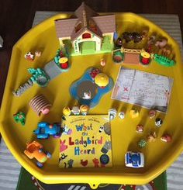  Find some of the animals in the story and try and use them to retell the story.
Creative  Expressive Arts & Design – Exploring Using media and materials  - Manipulates materials to achieve a planned effect (40-60 months)  - Realises tools can be used for a purpose. (40-60 months)  - Constructs with a purpose in mind, using a variety of resources. (40-60 months) | Get your child to help you make some playdough (see recipe below) and then use the playdough to make some ladybirds (great for pencil control) | 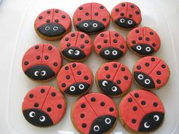  Make some ladybird biscuits –  please remember to wash your hands before cooking.  Use some biscuits and ice with red icing. Then add some black spots and eyes. Please load your photos onto your child’s DoJo portfolio

Super-easy Playdough Recipe
This super-easy playdough recipe is the perfect way to spend a rainy afternoon inside. It's quick enough to hold a young child's attention and you only need a few storecupboard ingredients. Little hands can play with the results straightaway, so there's immediate gratification for all involved!
Makes 1 coloured ball
Prep 10 minutes
You will need
- 8 tbsp plain flour
- 2 tbsp table salt
- 60ml warm water
- food colouring
- 1 tbsp vegetable oil
Method
1. Mix the flour and salt in a large bowl. In a separate bowl mix together the water, a few drops of food colouring and the oil.
2. Pour the coloured water into the flour mix and bring together with a spoon.
3. Dust a work surface with a little flour and turn out the dough. Knead together for a few minutes to form a smooth, pliable dough. If you want a more intense colour you can work in a few extra drops of food colouring.
4. Store in a plastic sandwich bag (squeeze out the air) in the fridge to keep it fresh. You can make a batch of colours and give away as kids’ party bag favours or hold a playdough party for your child’s next birthday.

Over the next couple of weeks, I will be communicating with parents during the new class DoJo app – please can you make sure that you have accepted the invitation to your child’s learning so that we can work together to support your child’s learning at home. I love seeing photos of your child completing some of the activities.

Please contact me via email on mhorrell@exmoorlink.org if you need any further guidance.

